**Credit Card Online Banking Application**

**Features to develop:**

1.Develop Login Module

2.Netbanking Dashboard

3.Profile

**Installing Jira and Creating a project**

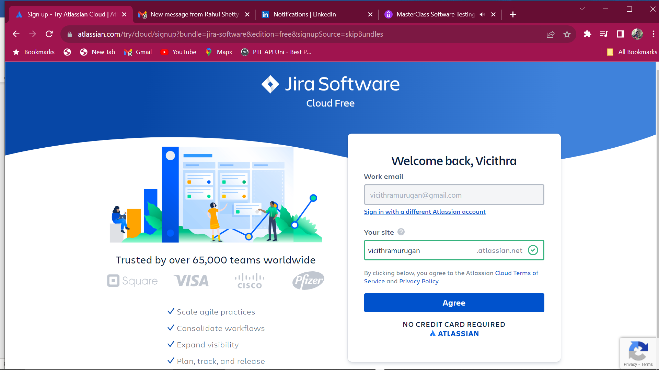

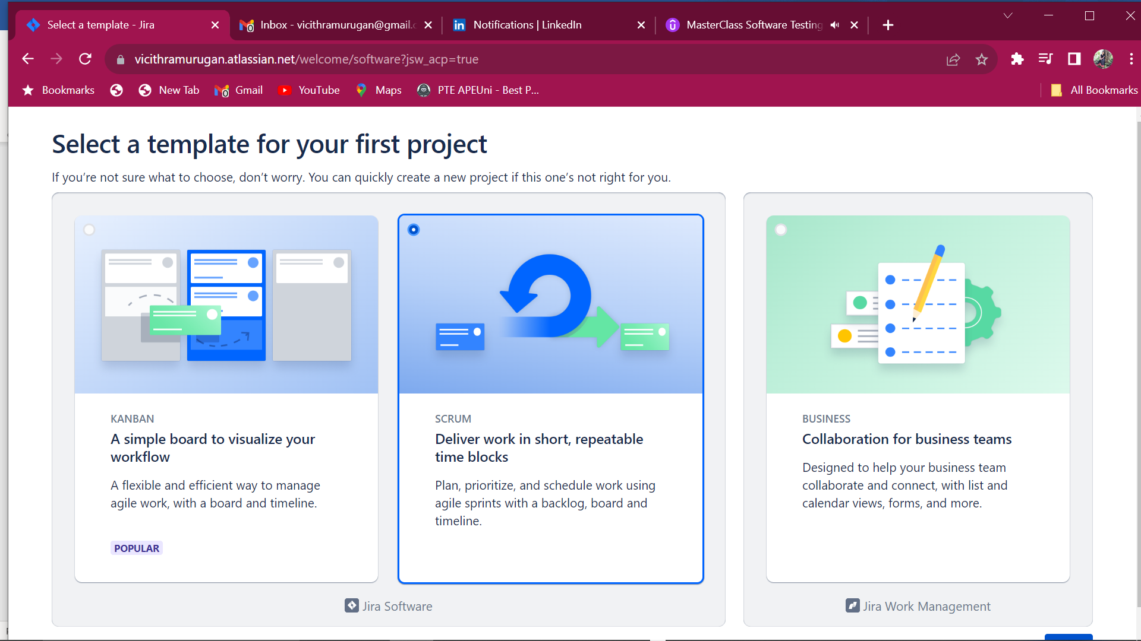

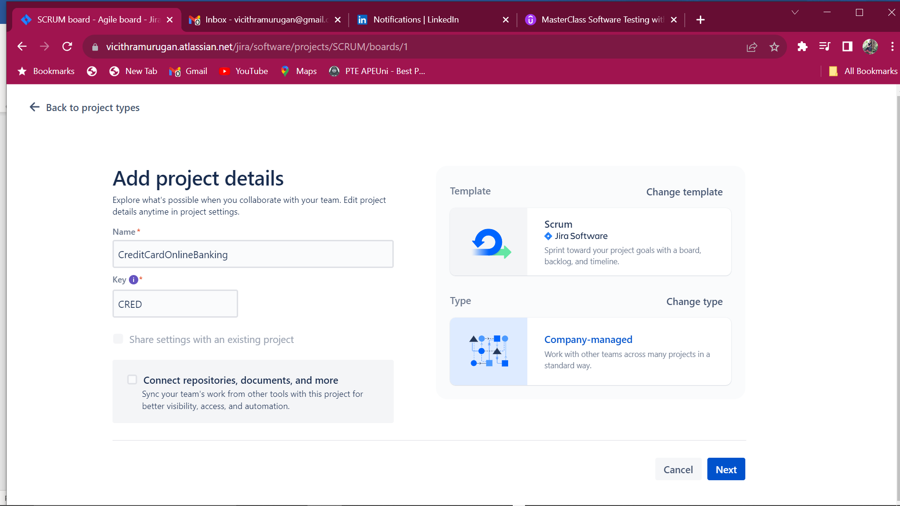

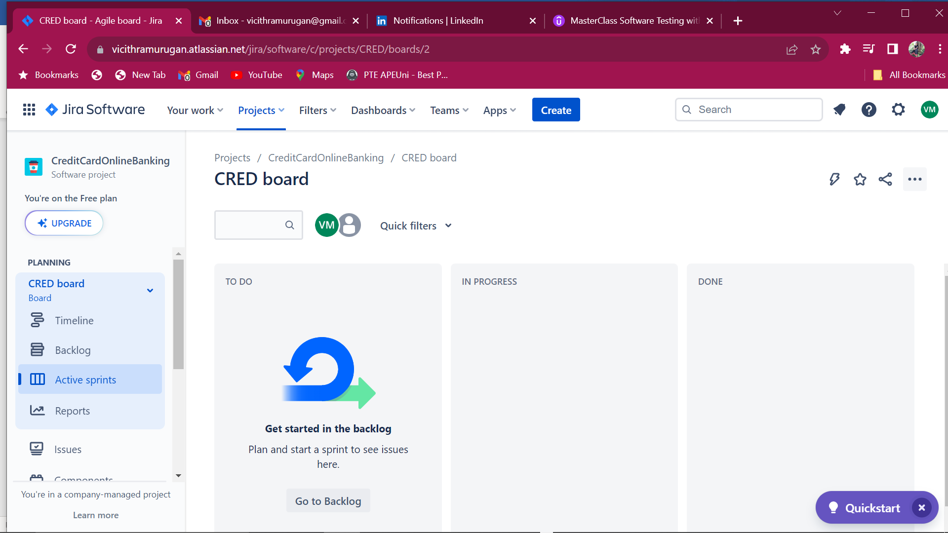

**Features are termed as Epic**

**Create Epic for the first feature – Implement Login Details**

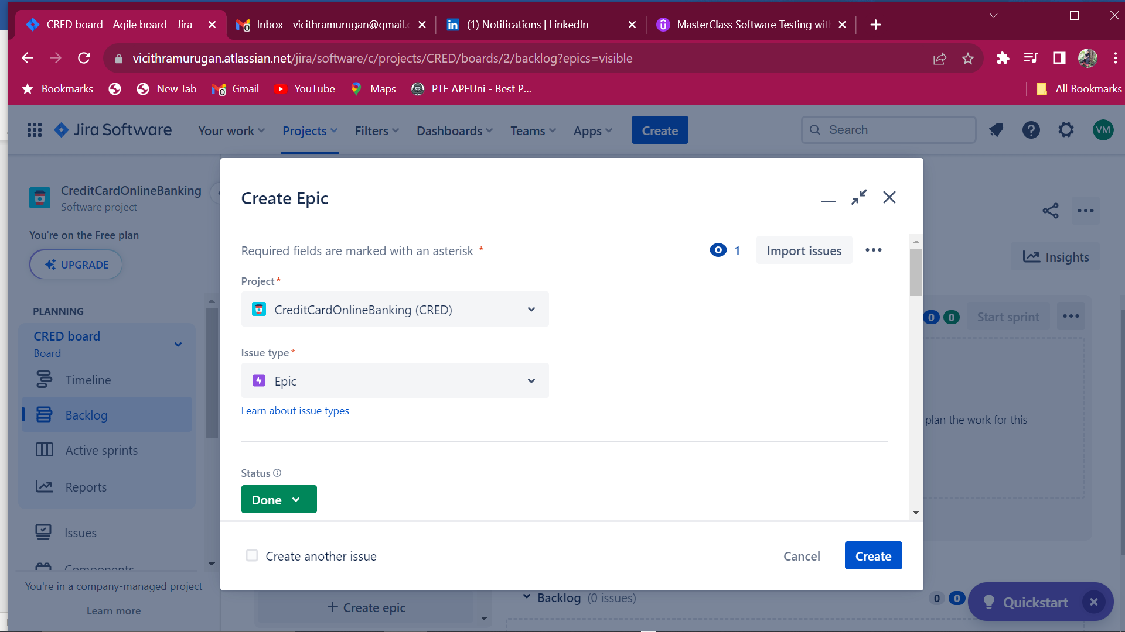

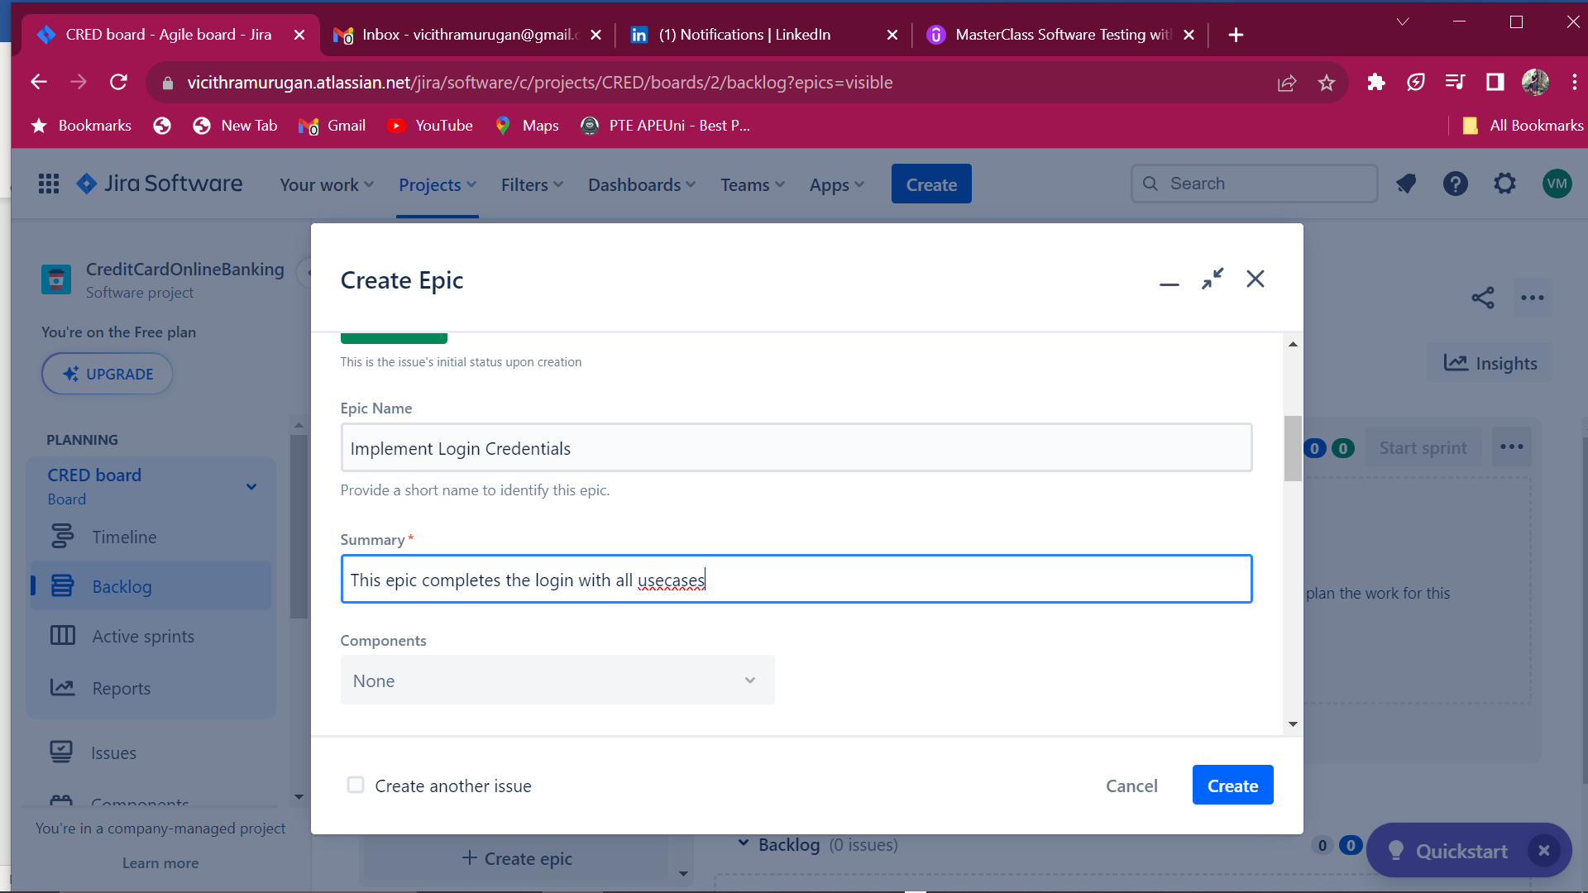

**Click create.**

**Creation of User Stories:**

**Click create tab**

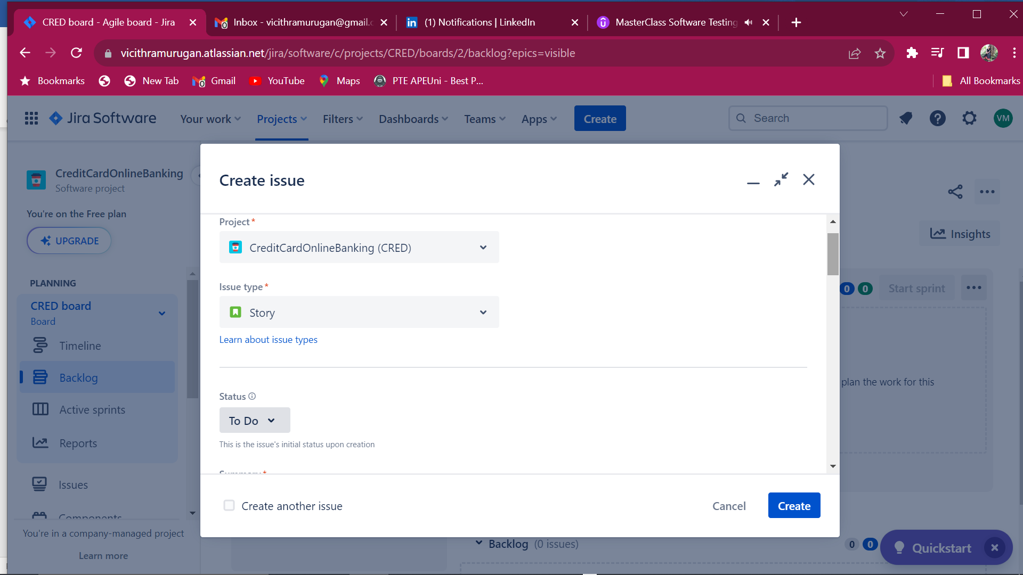

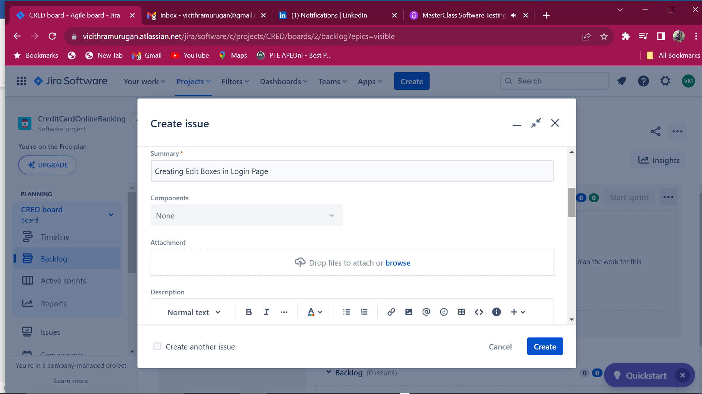

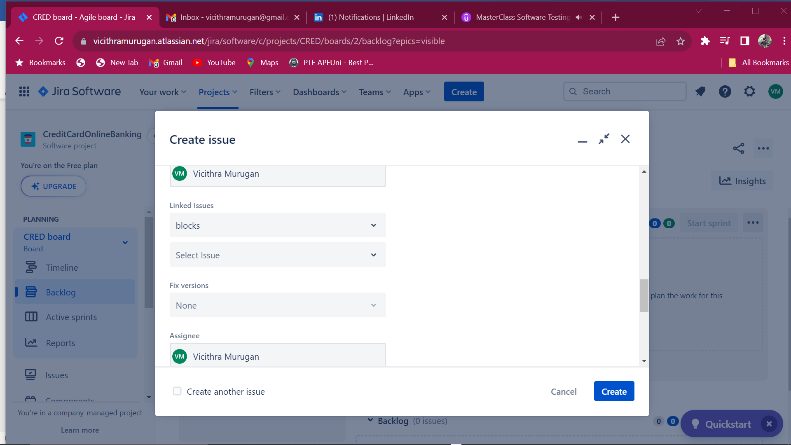

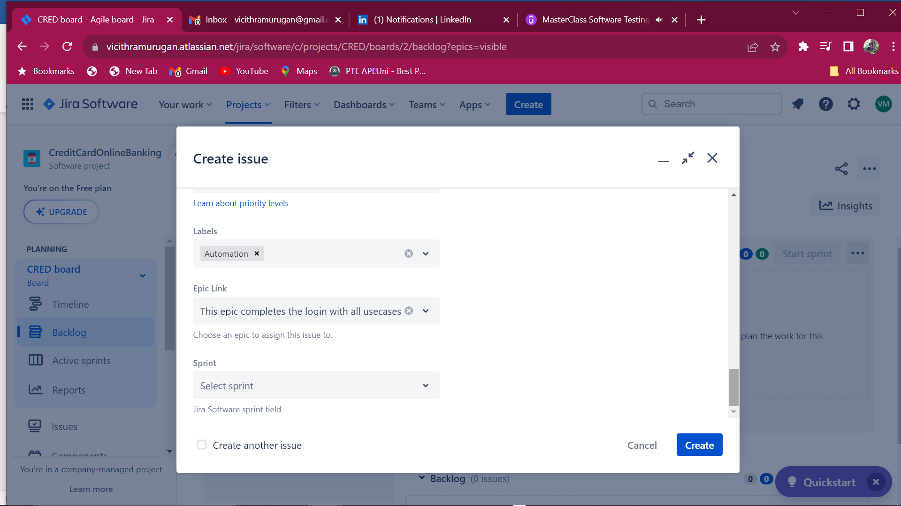

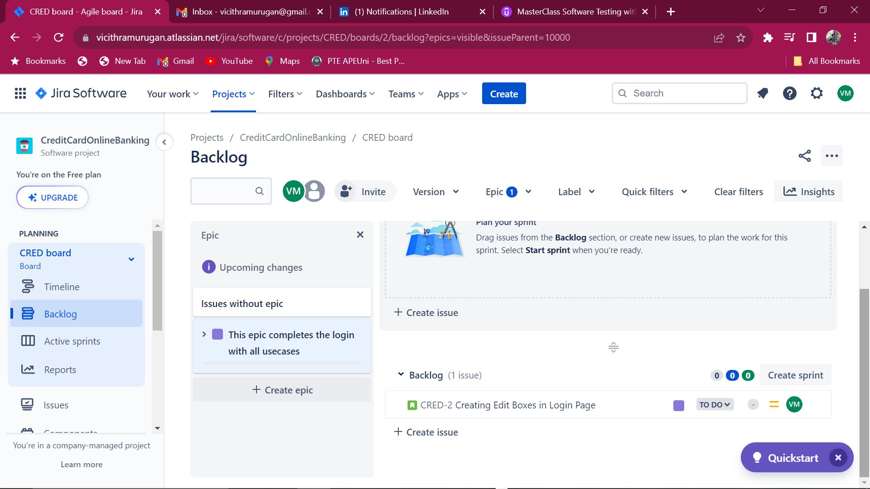

**Select Components – For assigning each team for specific functionality**

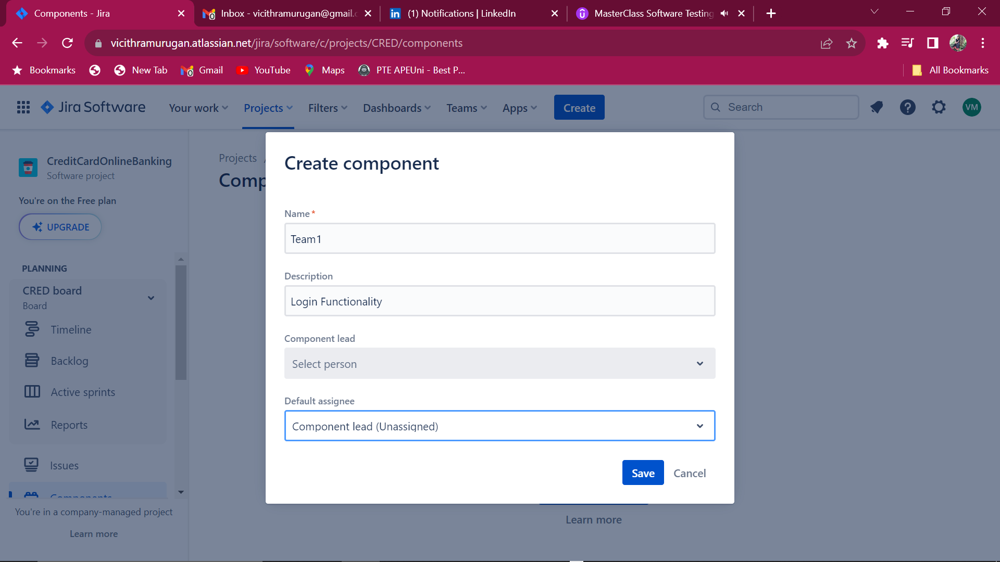

**Click save and now add that component to the Edit box stories**

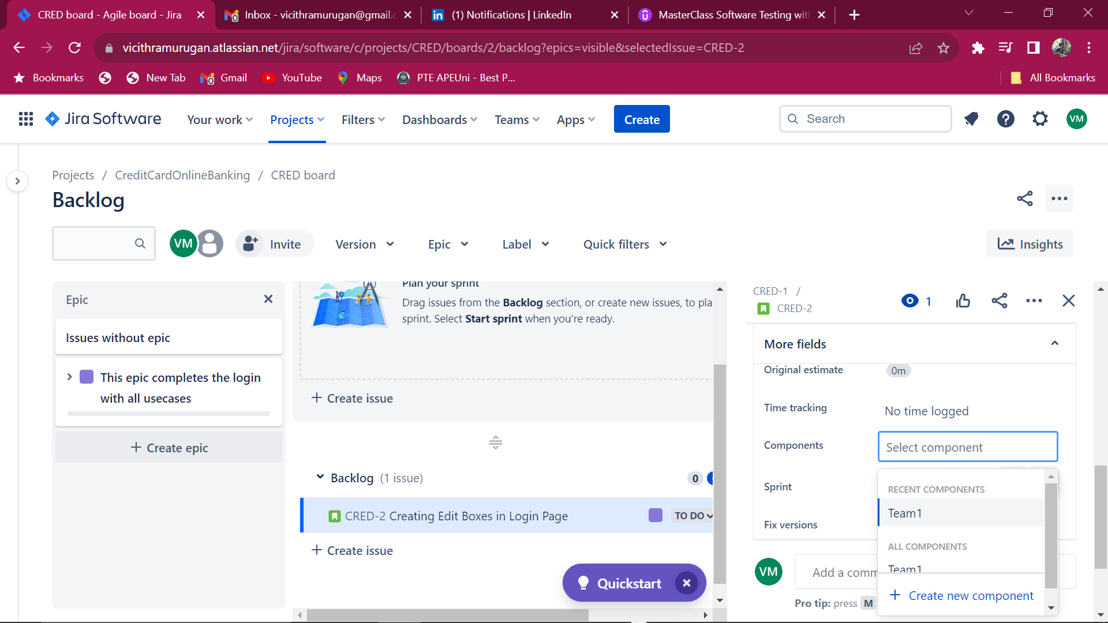

**Click create version.**

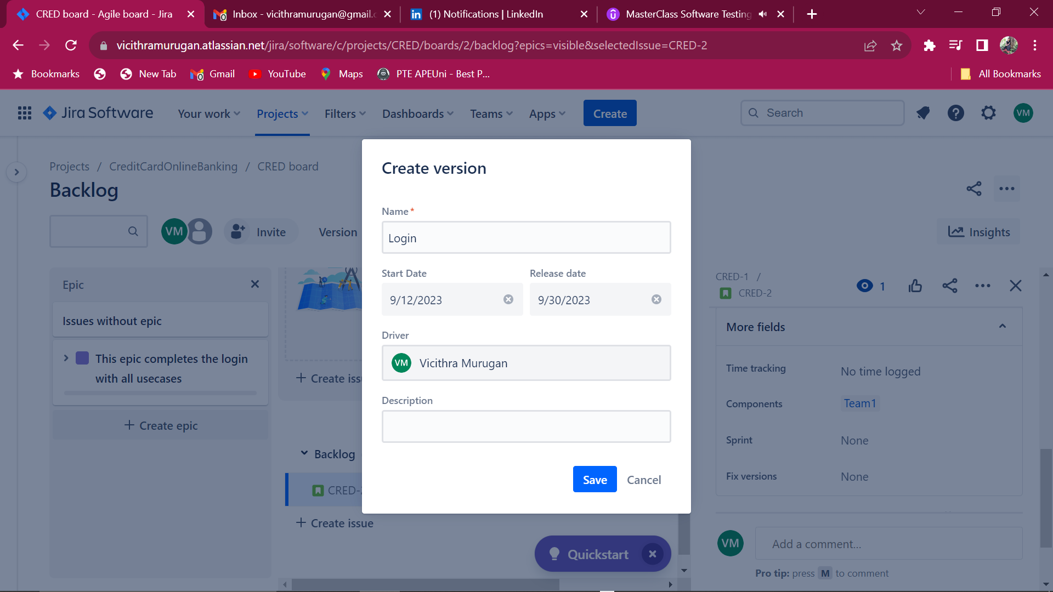

**Click save**

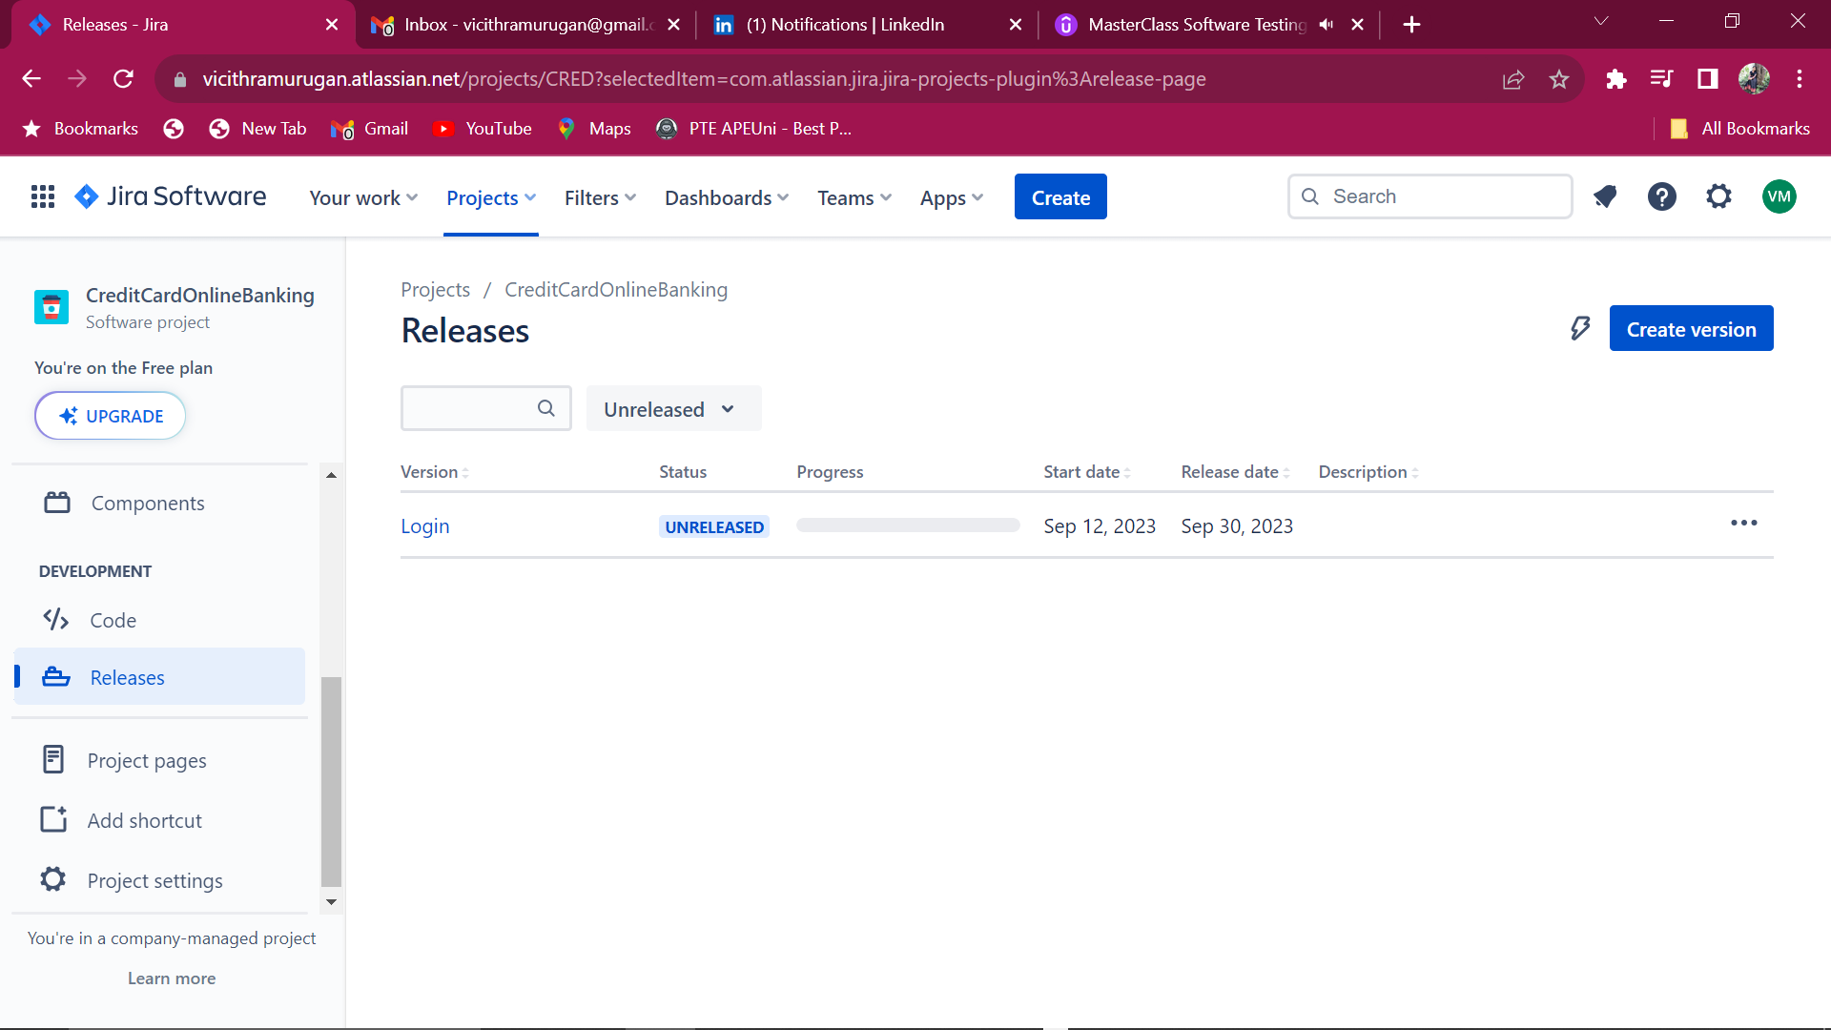

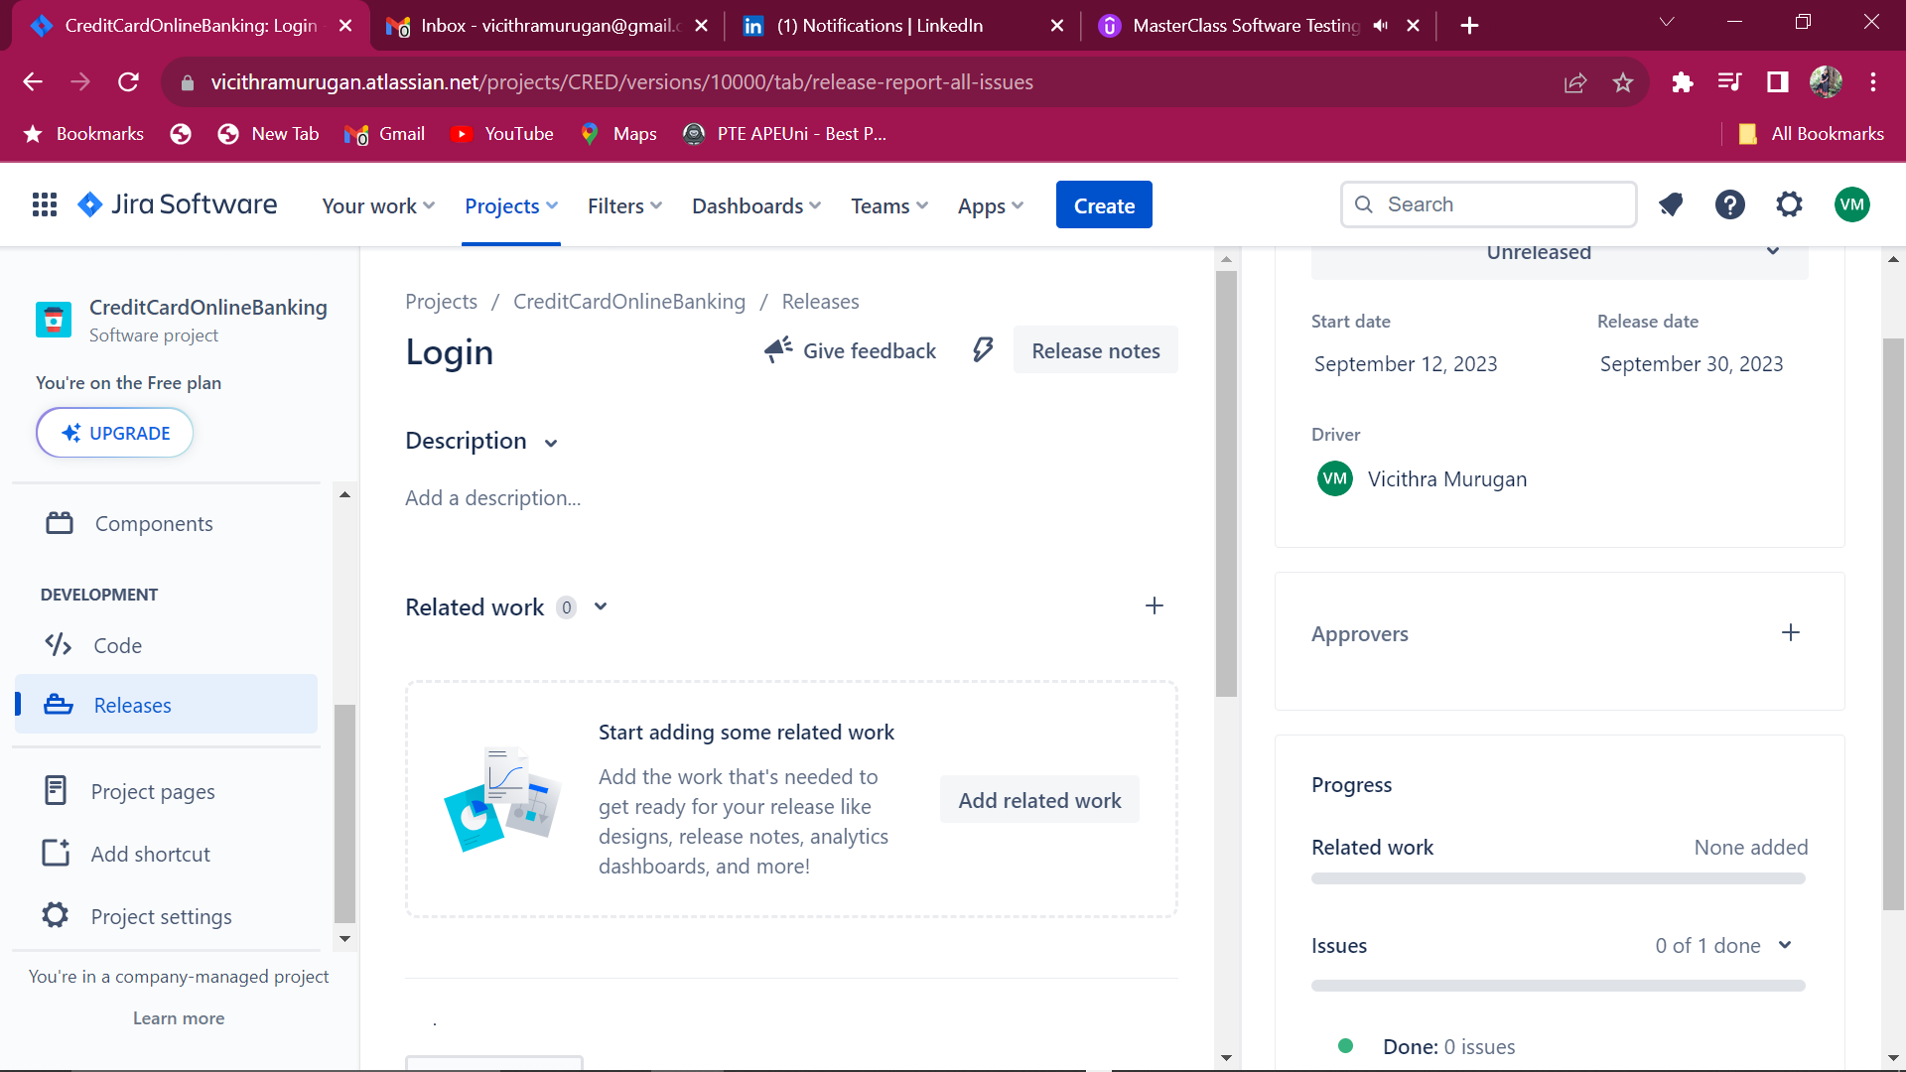

**Defining userstories for the Epic**

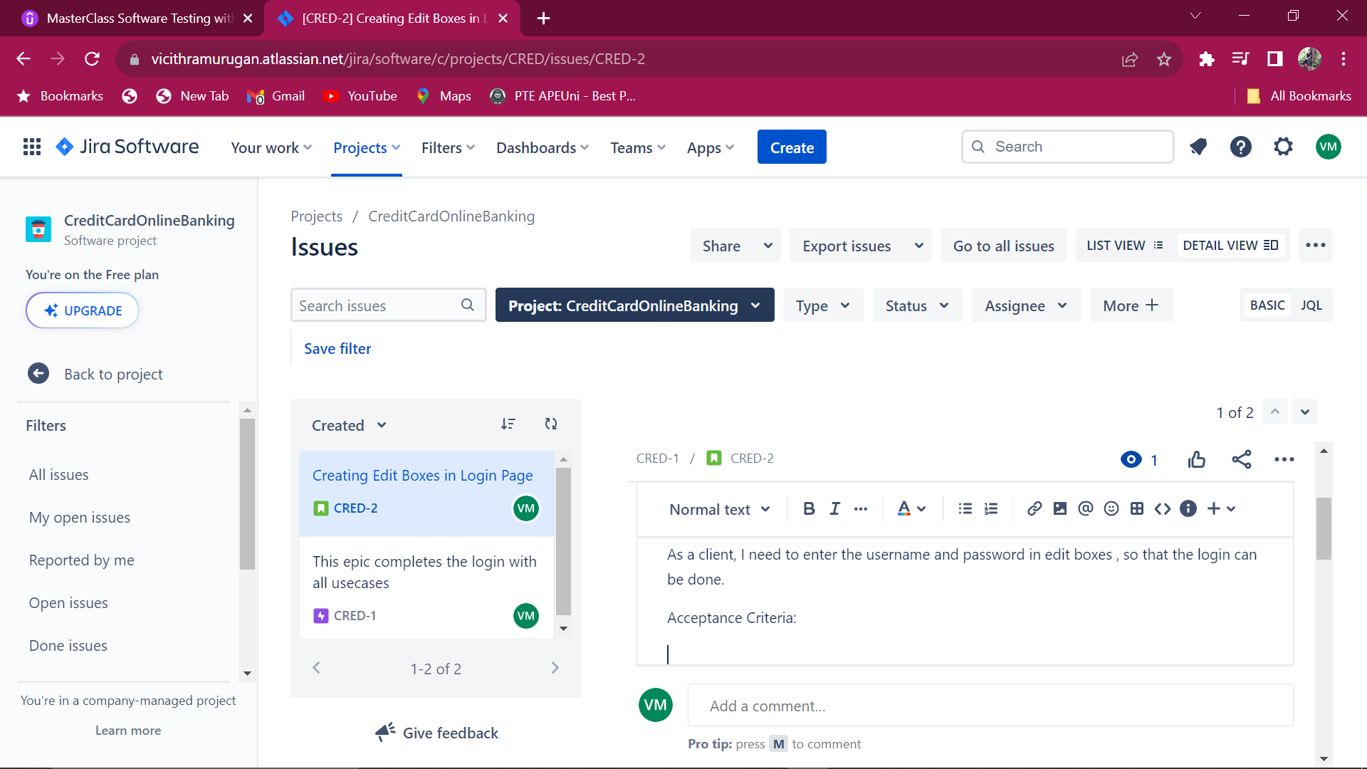

**Sample Page for Netbanking**

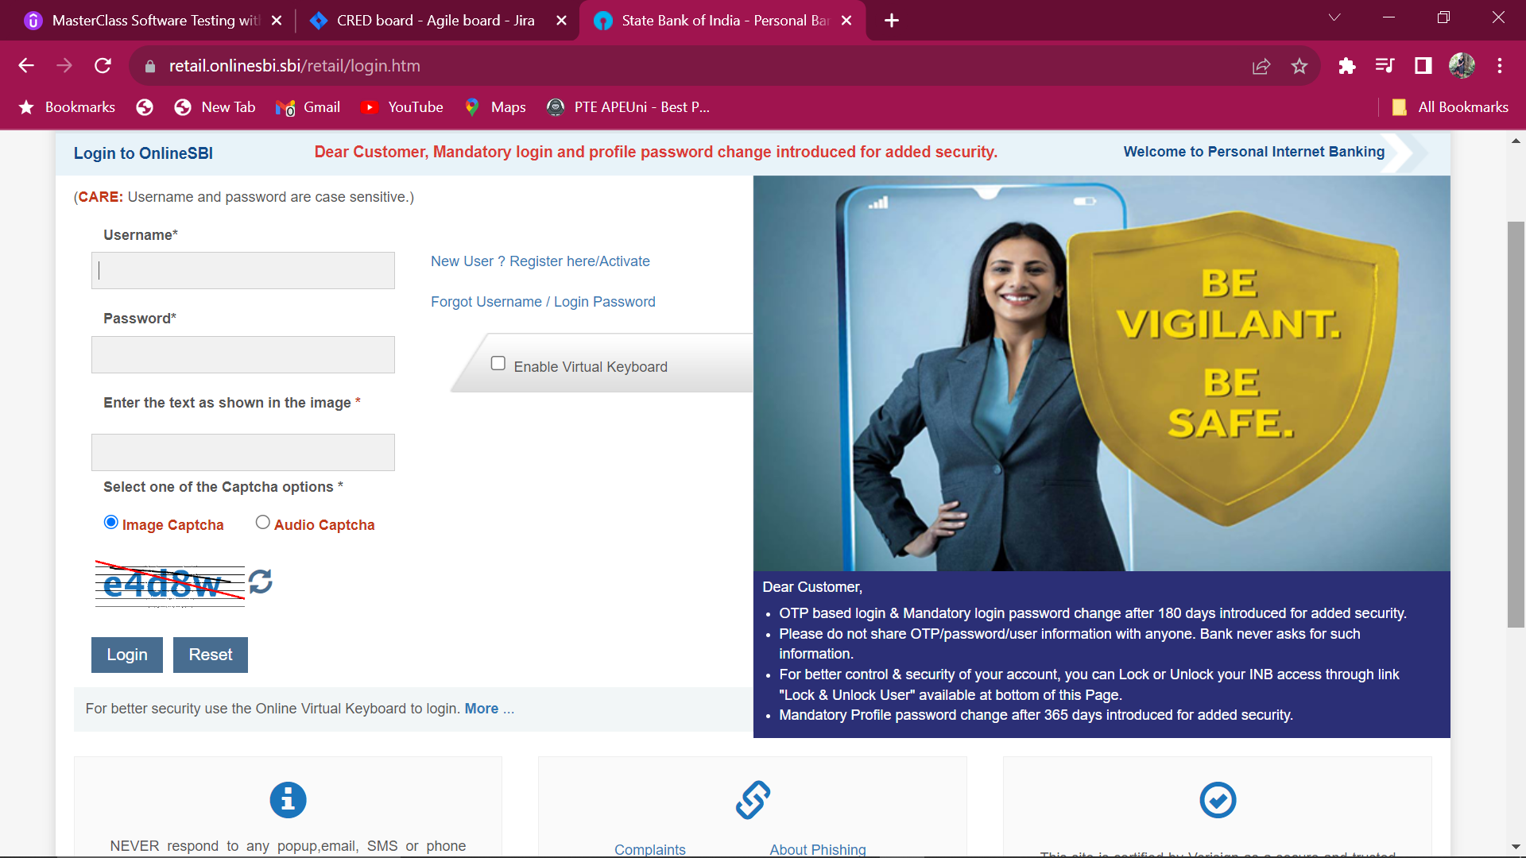

**Creating more backlogs**

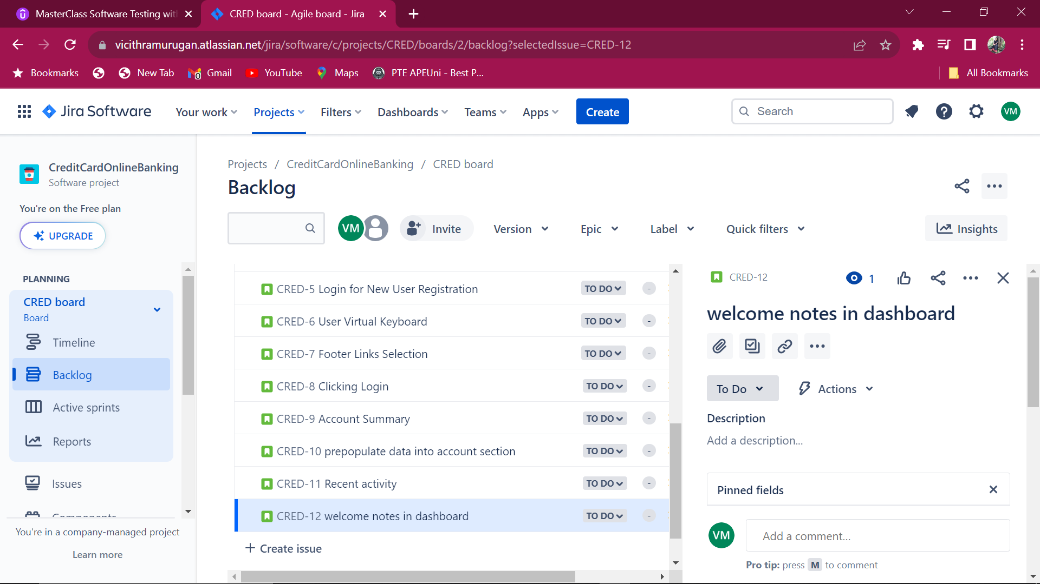

**Backlog Refinement or Grooming:**

Owner gives detailed information to the scrum team to write the User Acceptance Criteria.

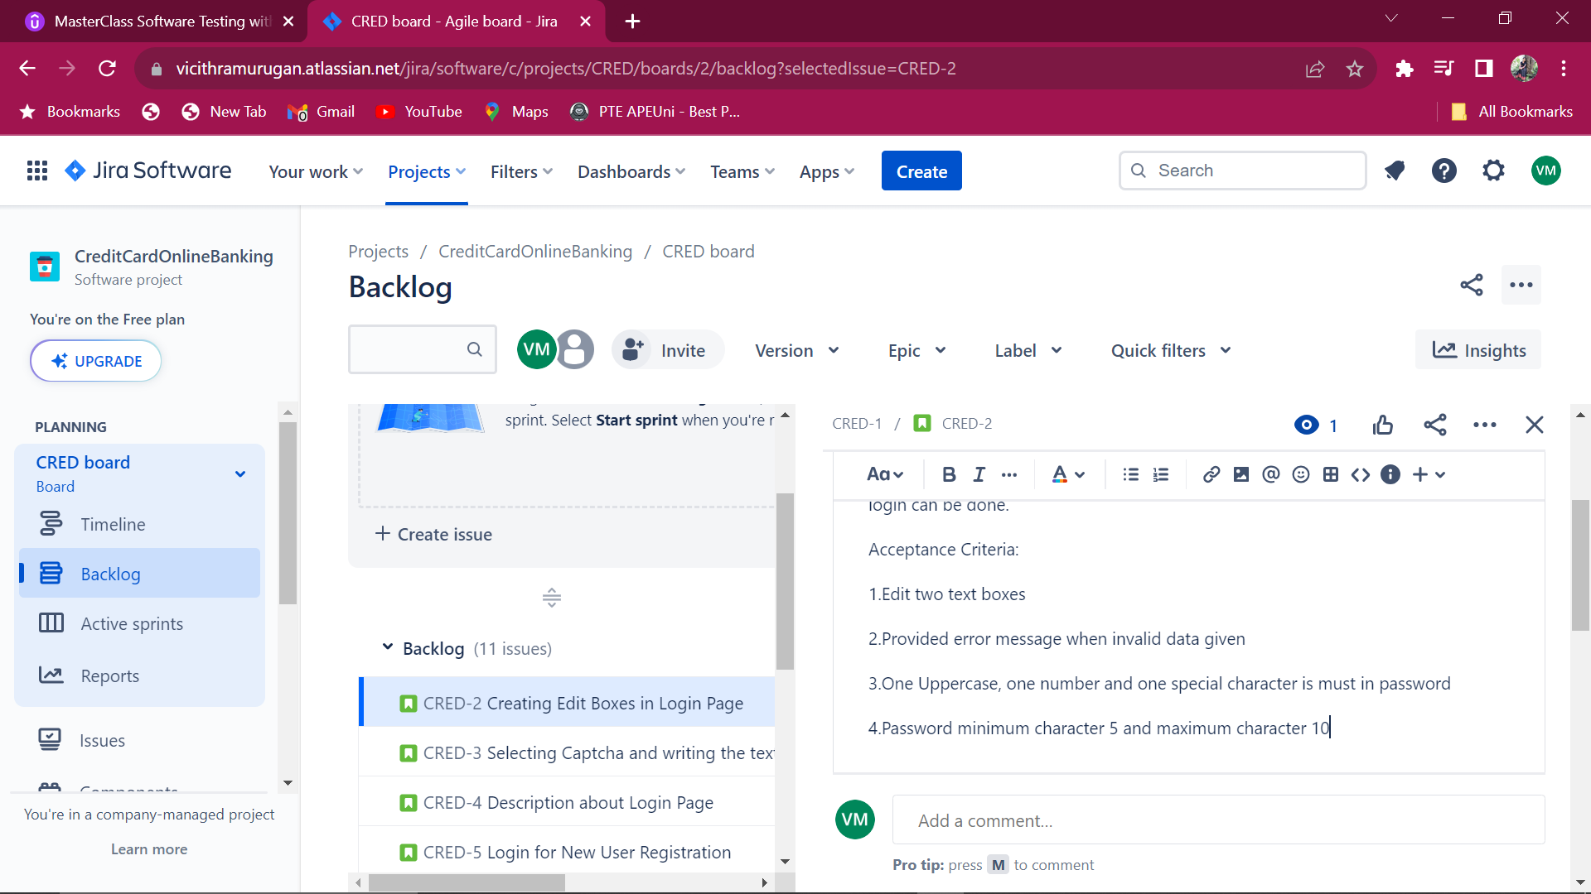

Efforts are termed as story points.Everyone in the team provide their own story points.Scrum master decides the majority efforts and note it down.

Lesser the story points, the task is simple.More the story points, the task is complicated.

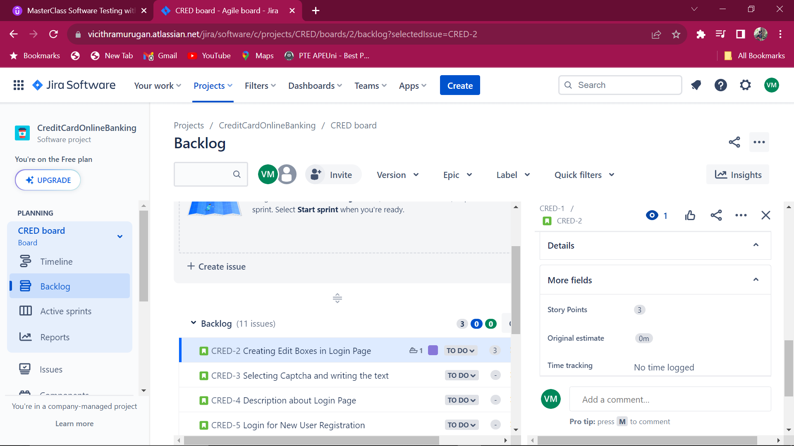

Adding comment will send the mail to that member or team

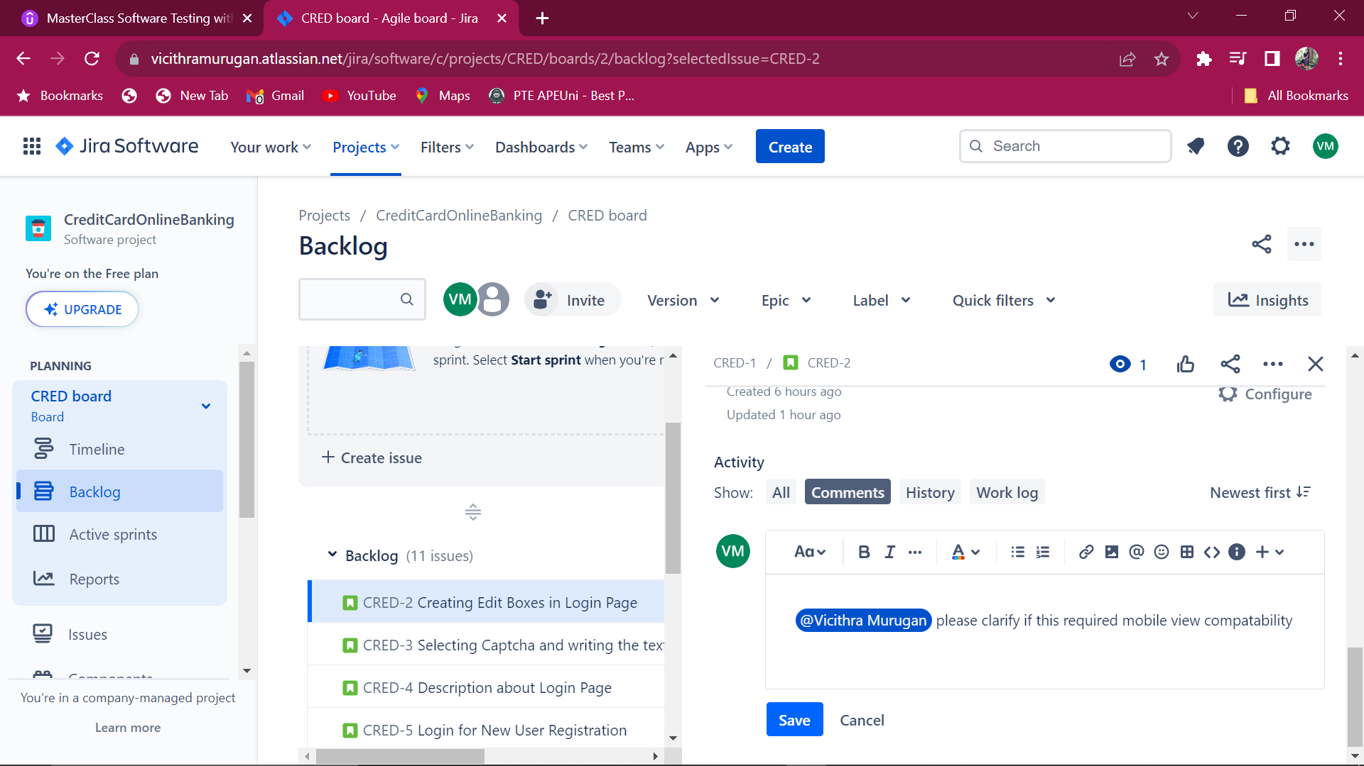

Creating substasks in Backlog Grooming

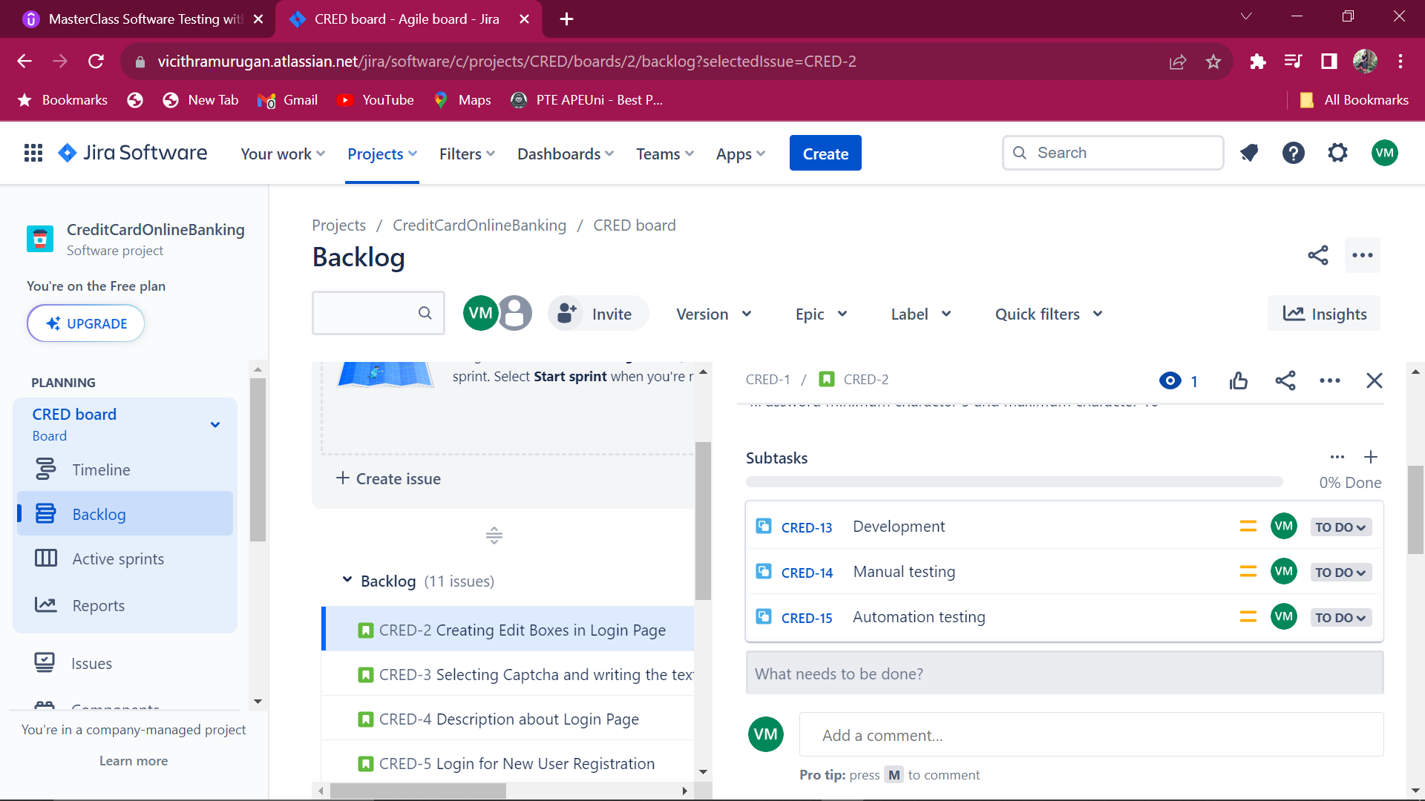

**Sprint Planning:**

Sprint is one timeboxed iteration of continuous development lifecycle.

In Agile methodology, every sprint has its own release

After discussion with the team , the estimation is finalized as 10.

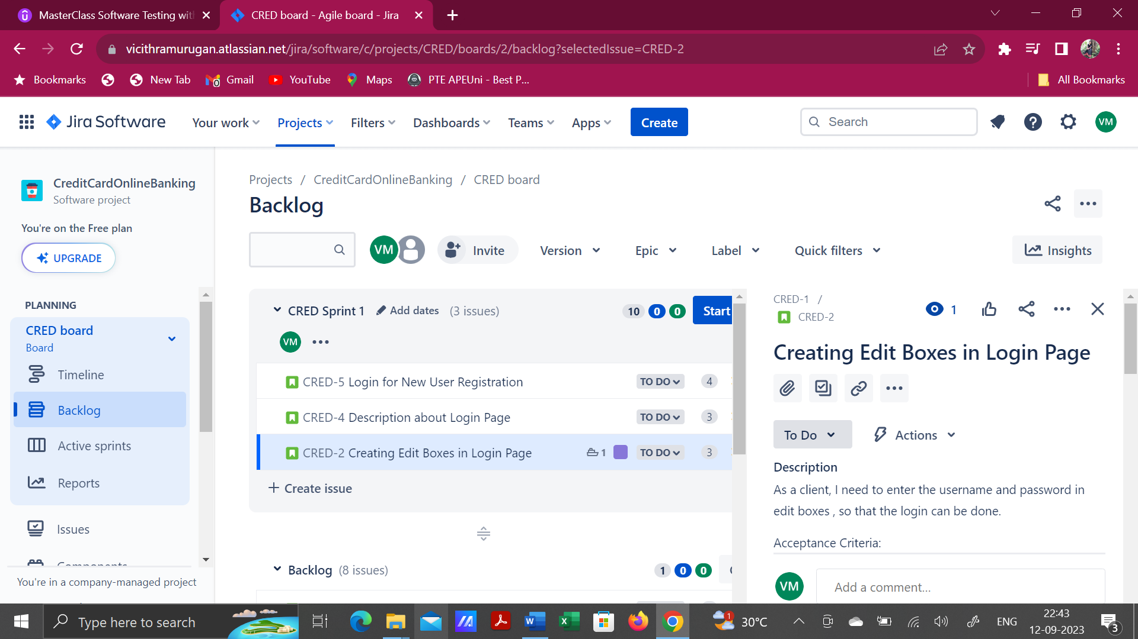

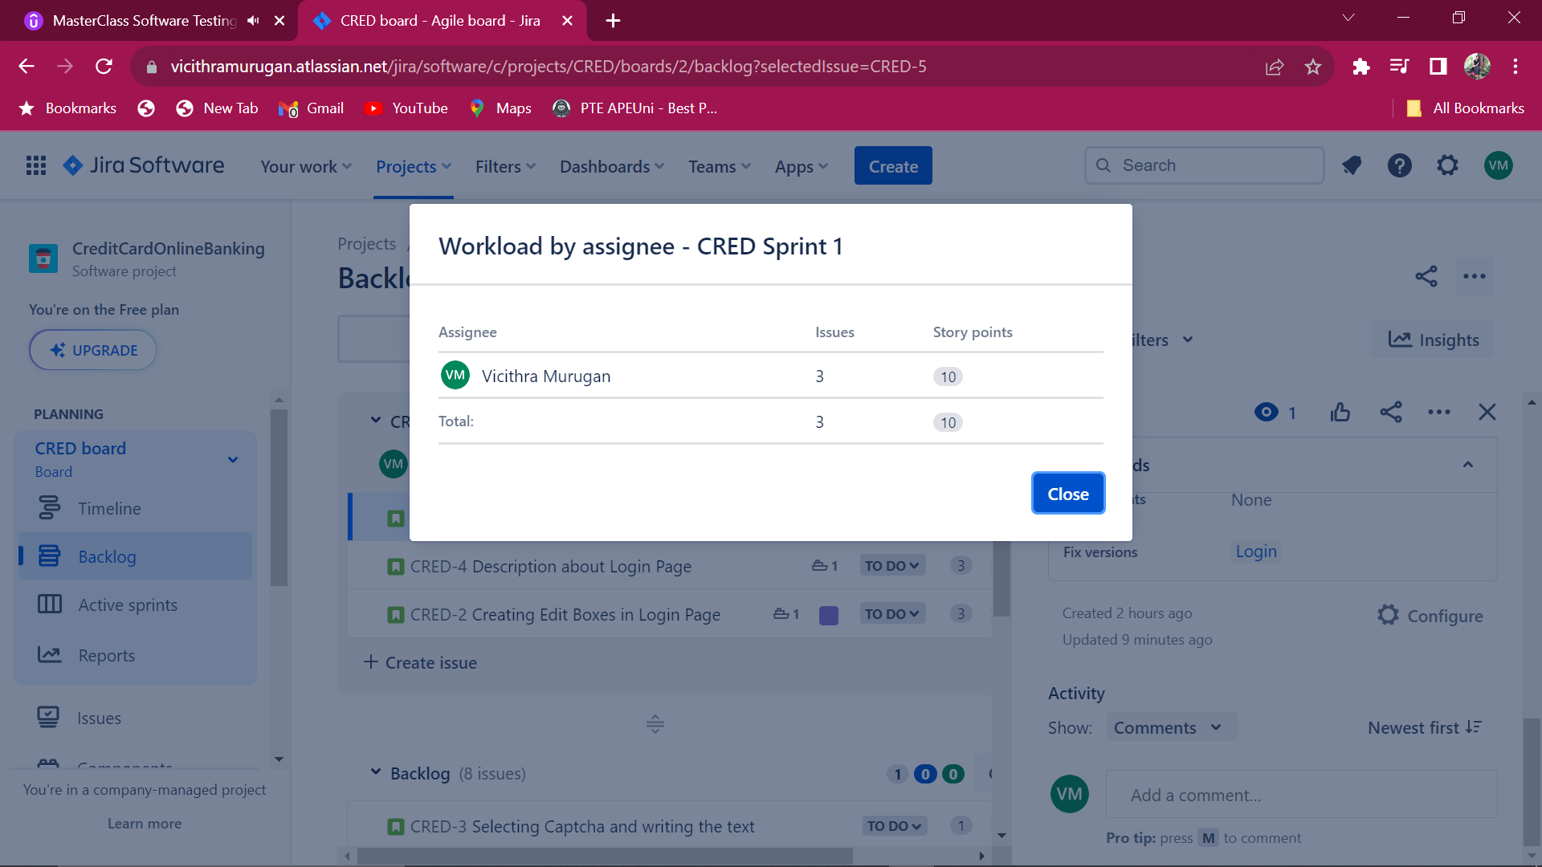

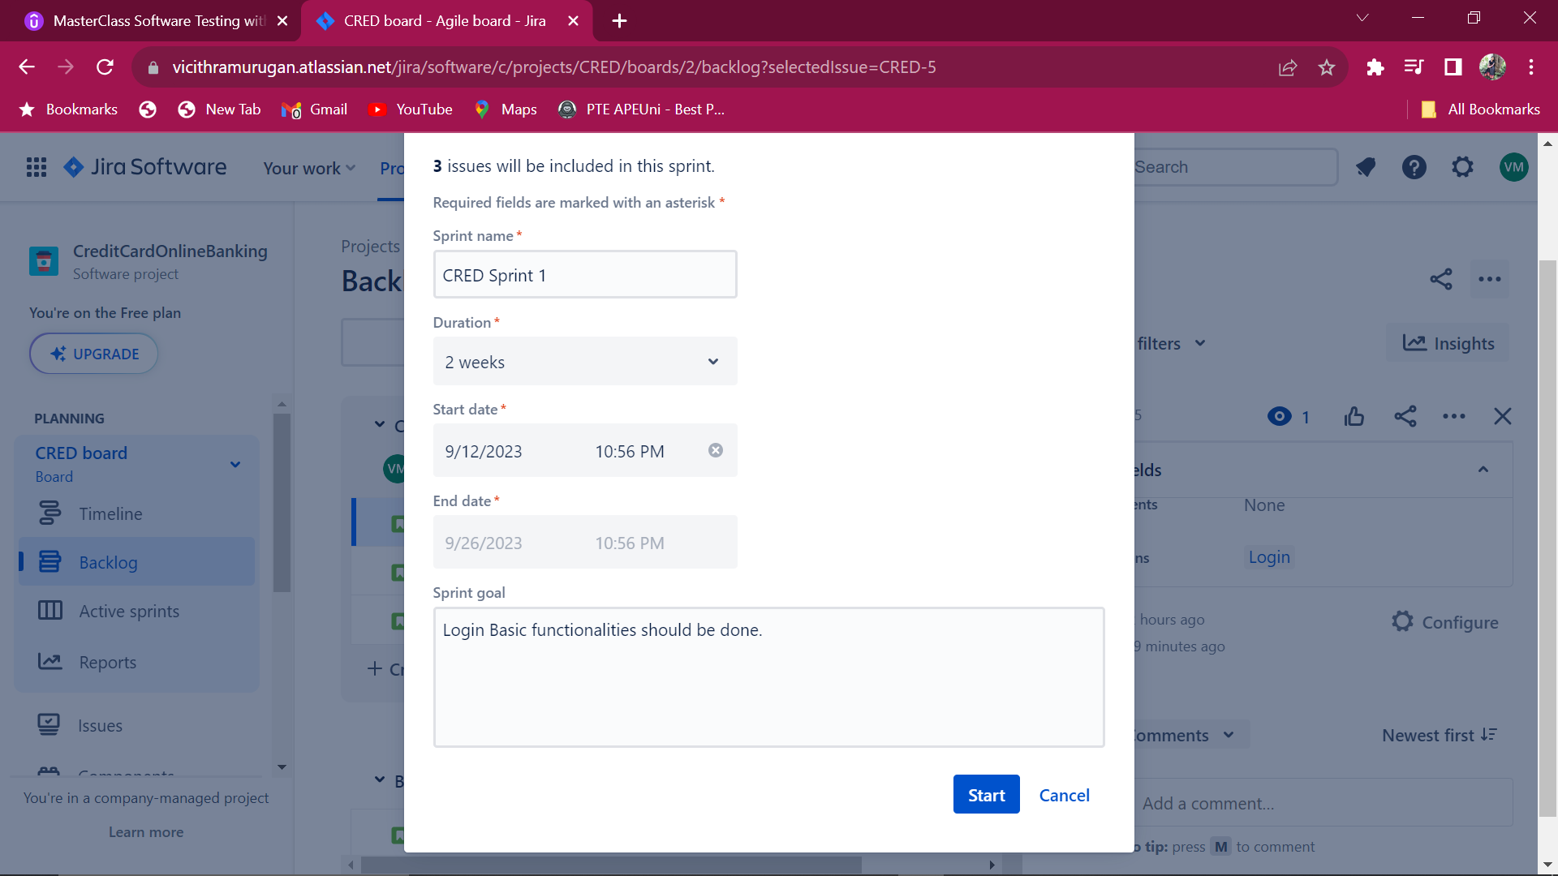

Showing Active Sprints

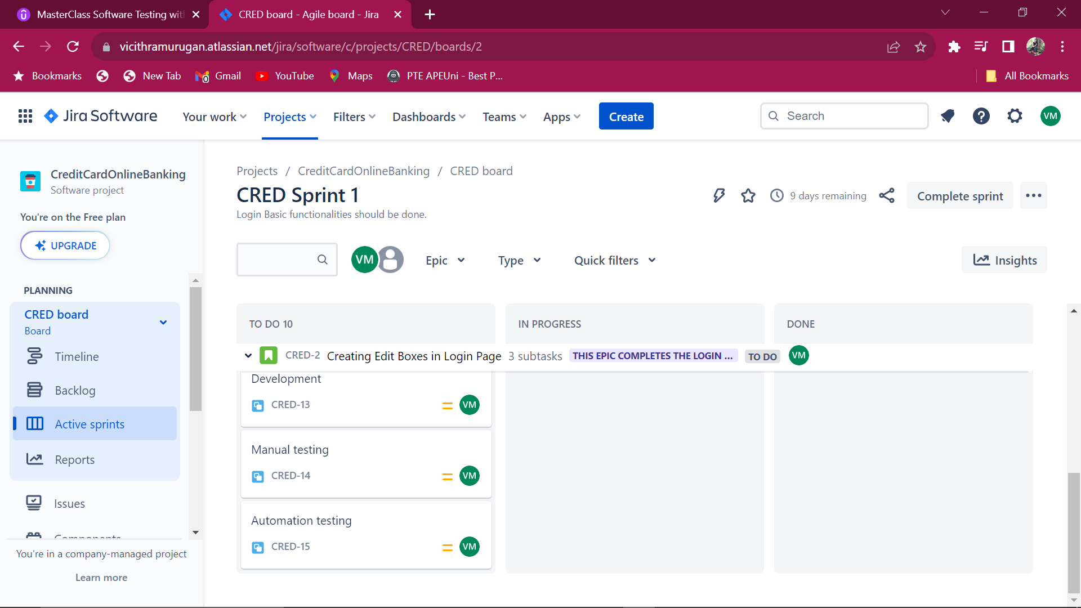

Change the status to inprogress while doing the process.

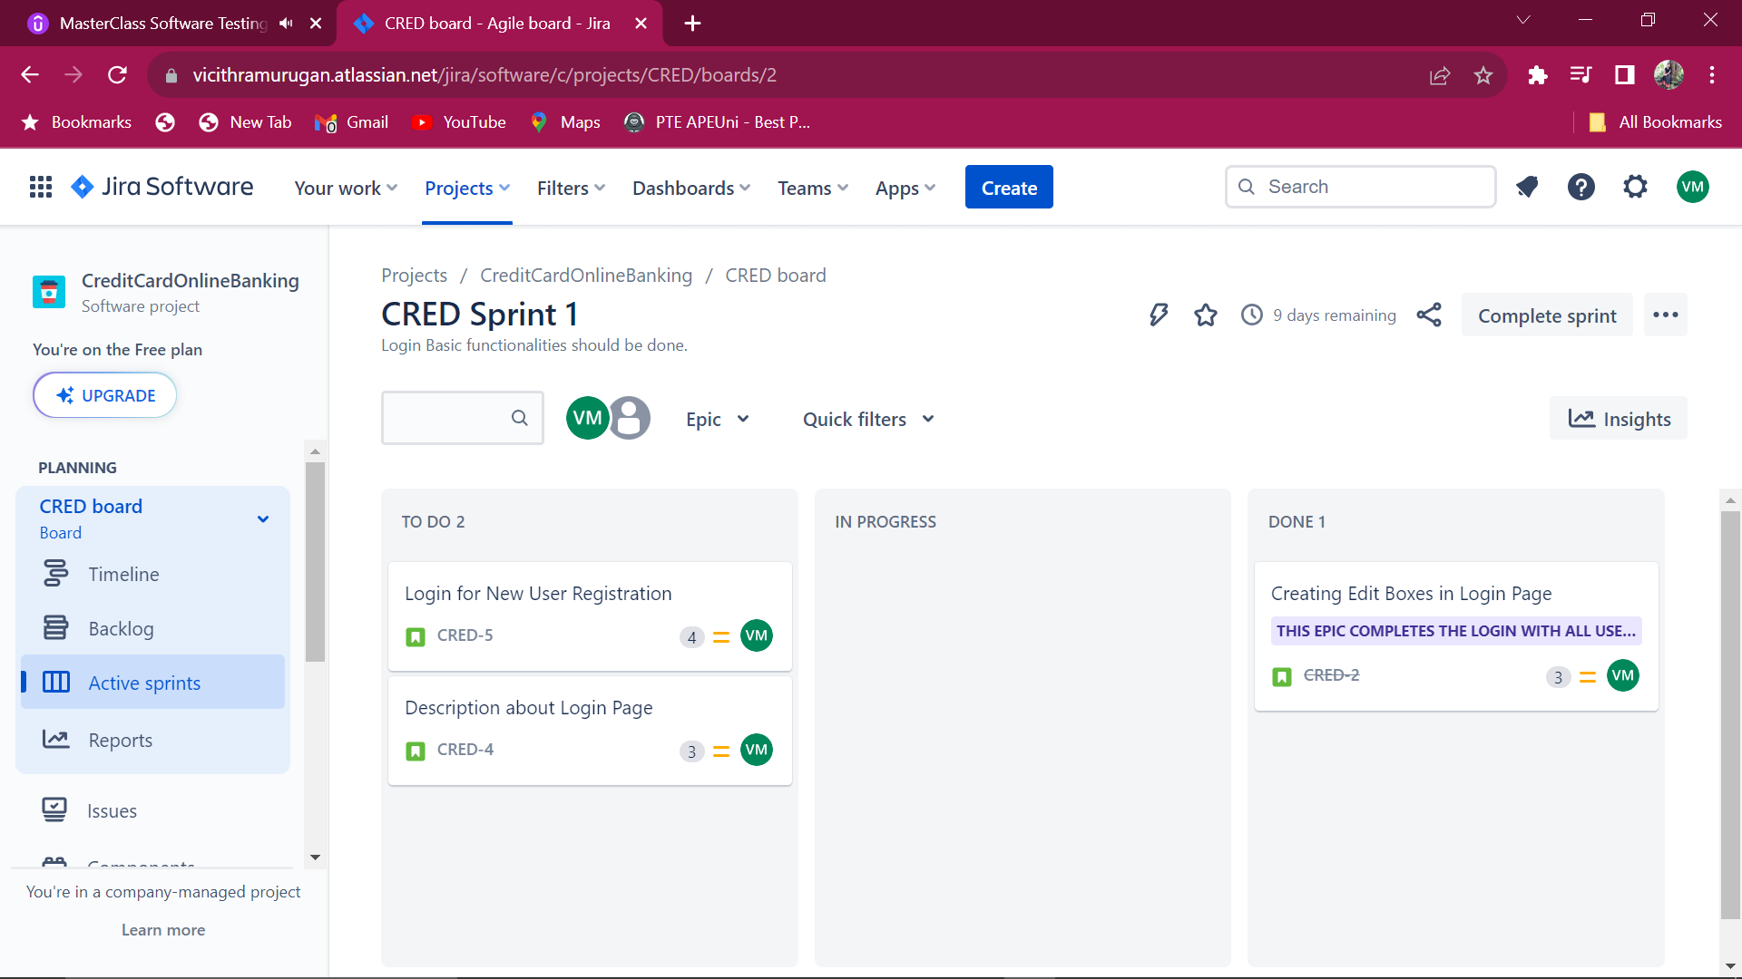

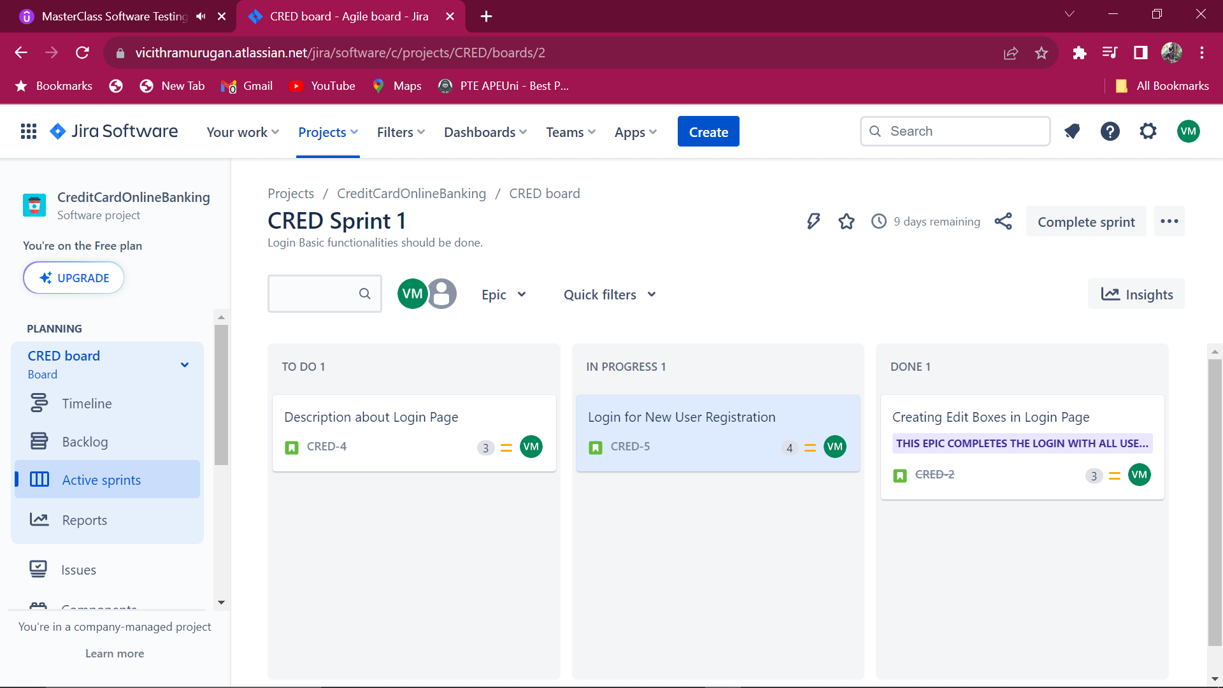

Once All the user stories are done, click complete sprint.

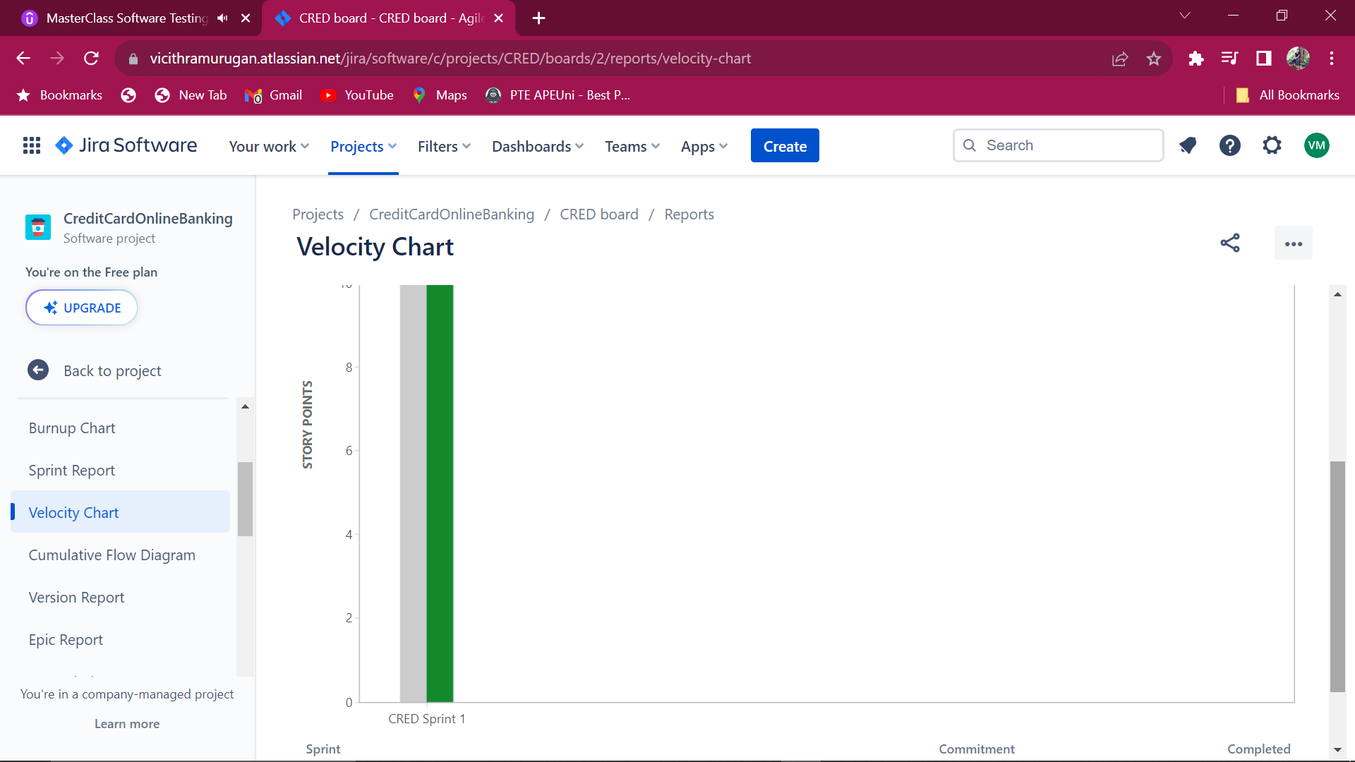

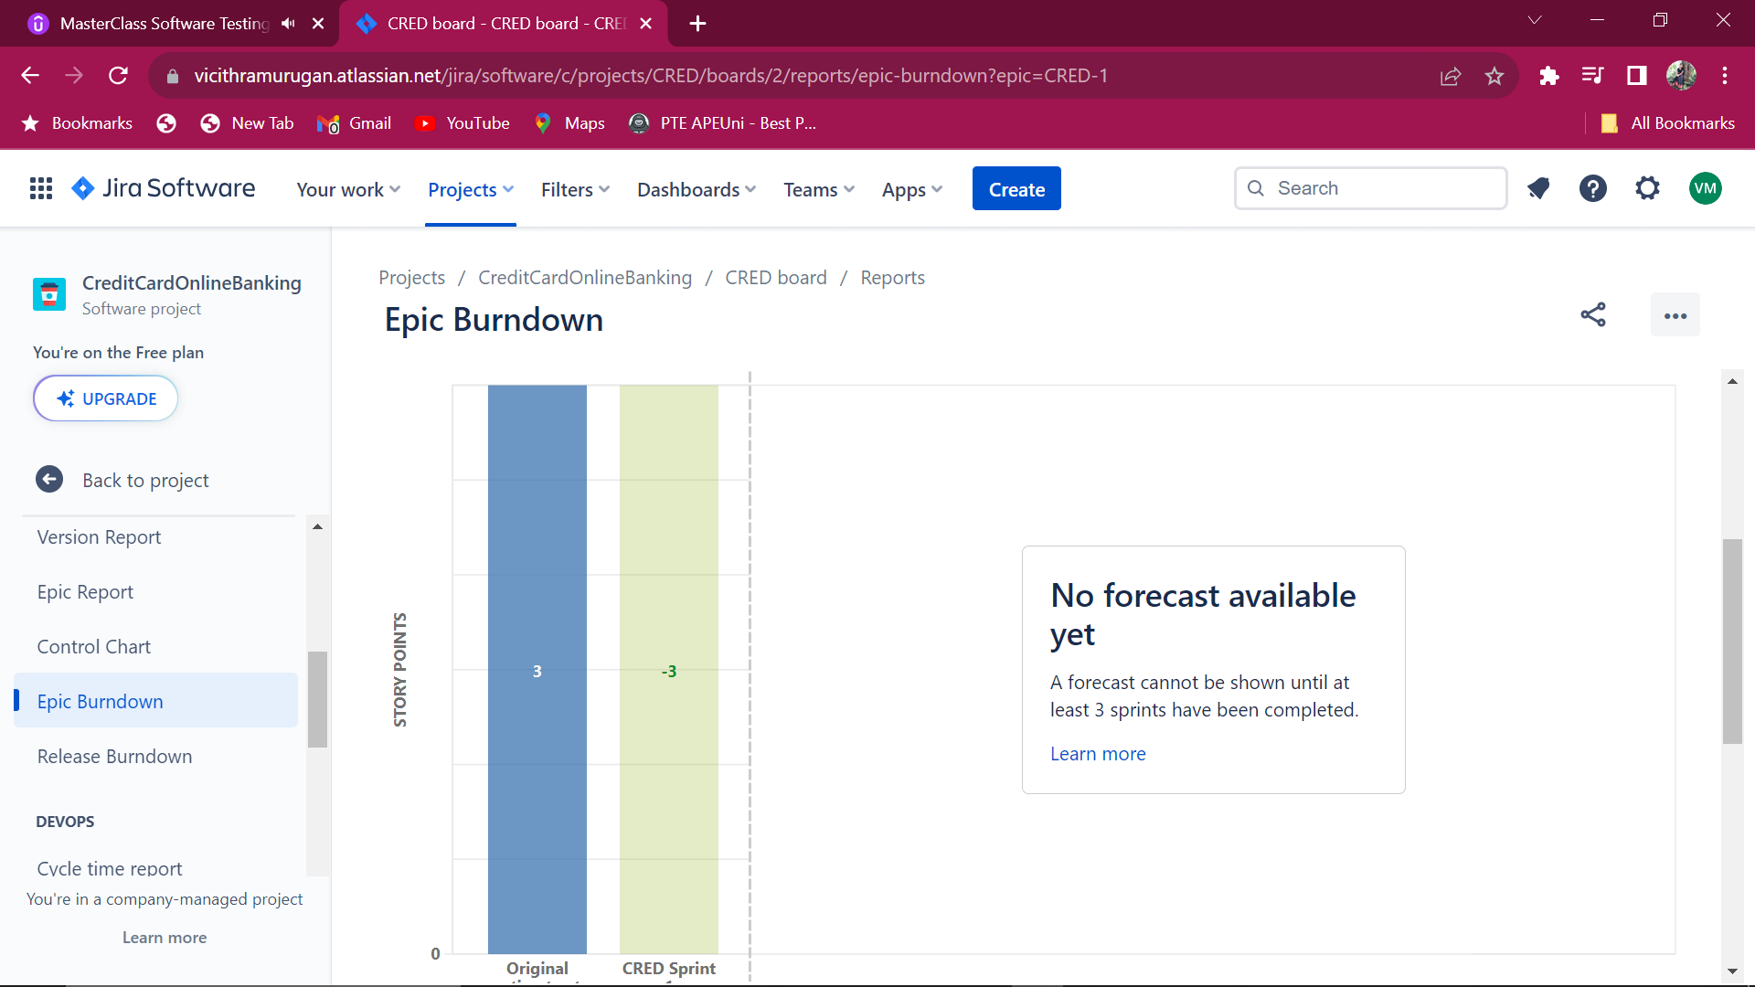

**Creating Bug**

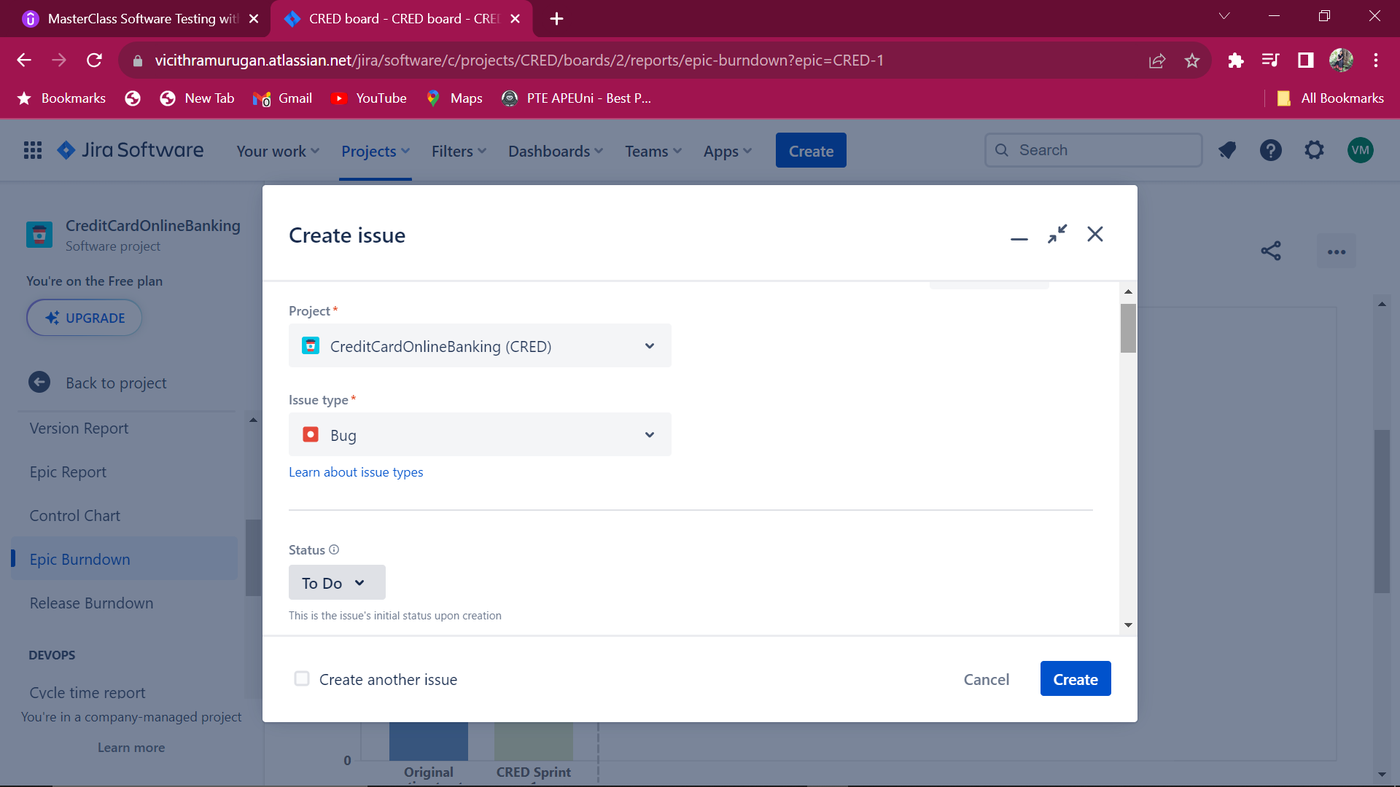

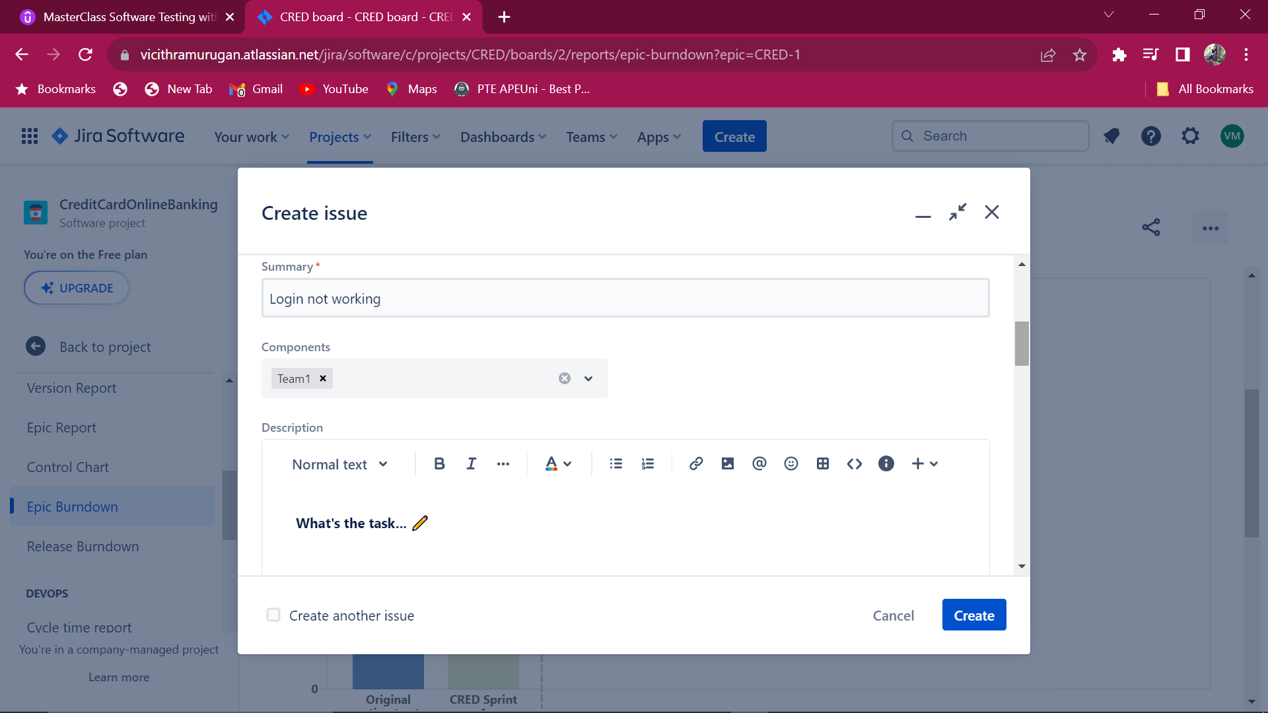

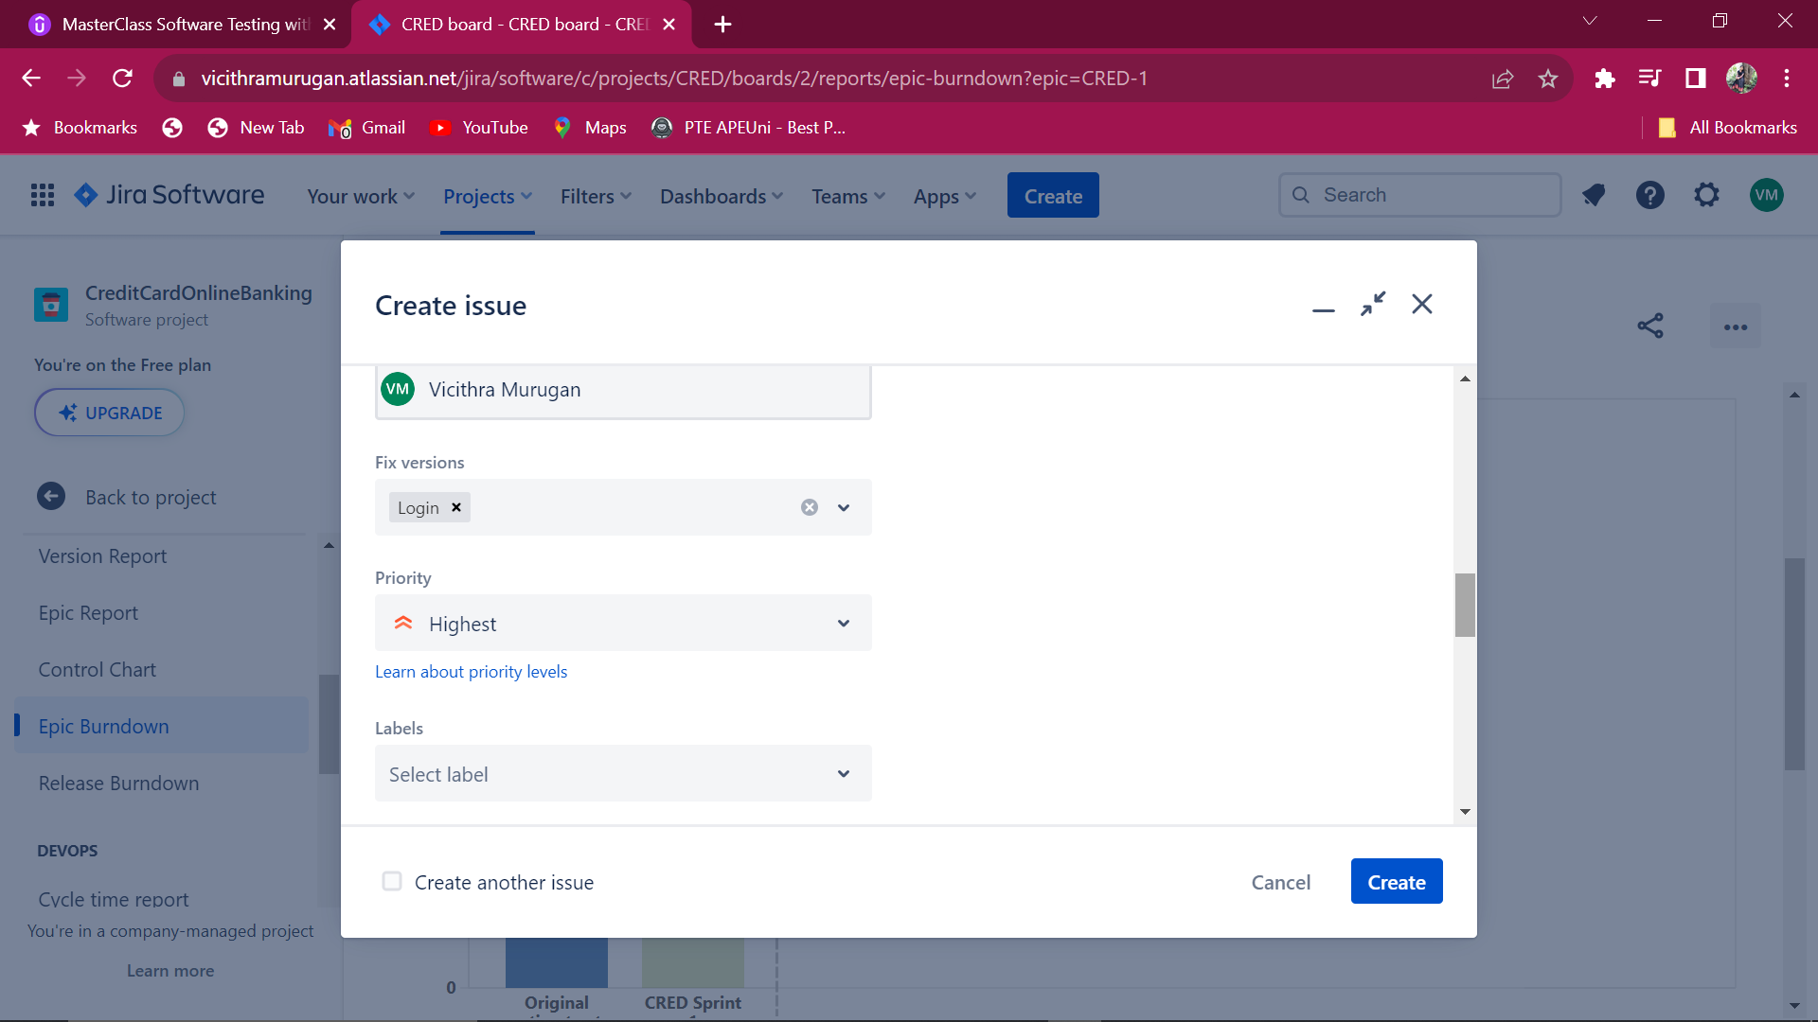

**Bug creation is shown in Backlog**

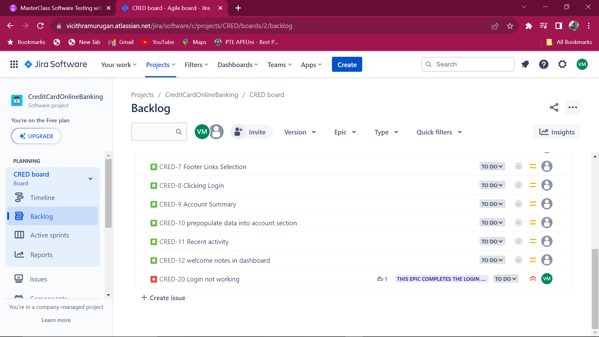

**Reporting Bug:**

**1.Retrospective:**

On the last day of sprint, meetings were done to discuss “what went well and what didn’t went well” and its causes.It may be due to dependencies issues or environment issues.

2.**In Kanban board:**

Deadline is marked, all the backlogs are in todo list. It can be progressed in on-demand basis.

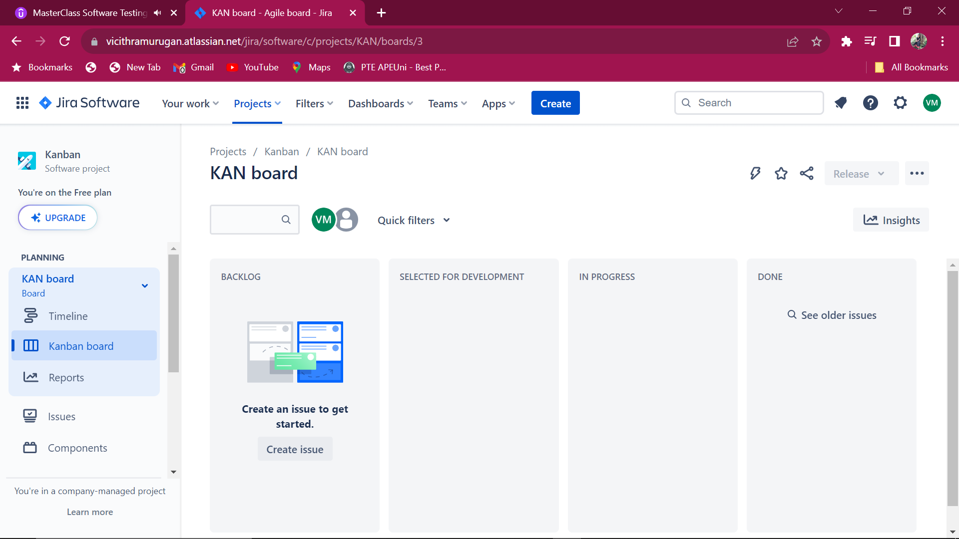

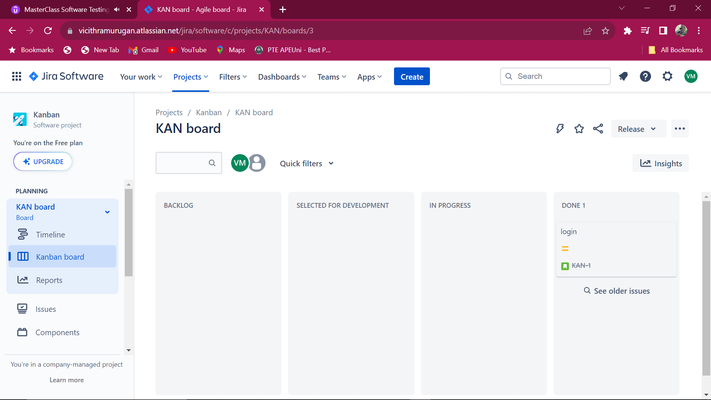

**XRAY- It is an app in JIRA for writing testcases and it output.**

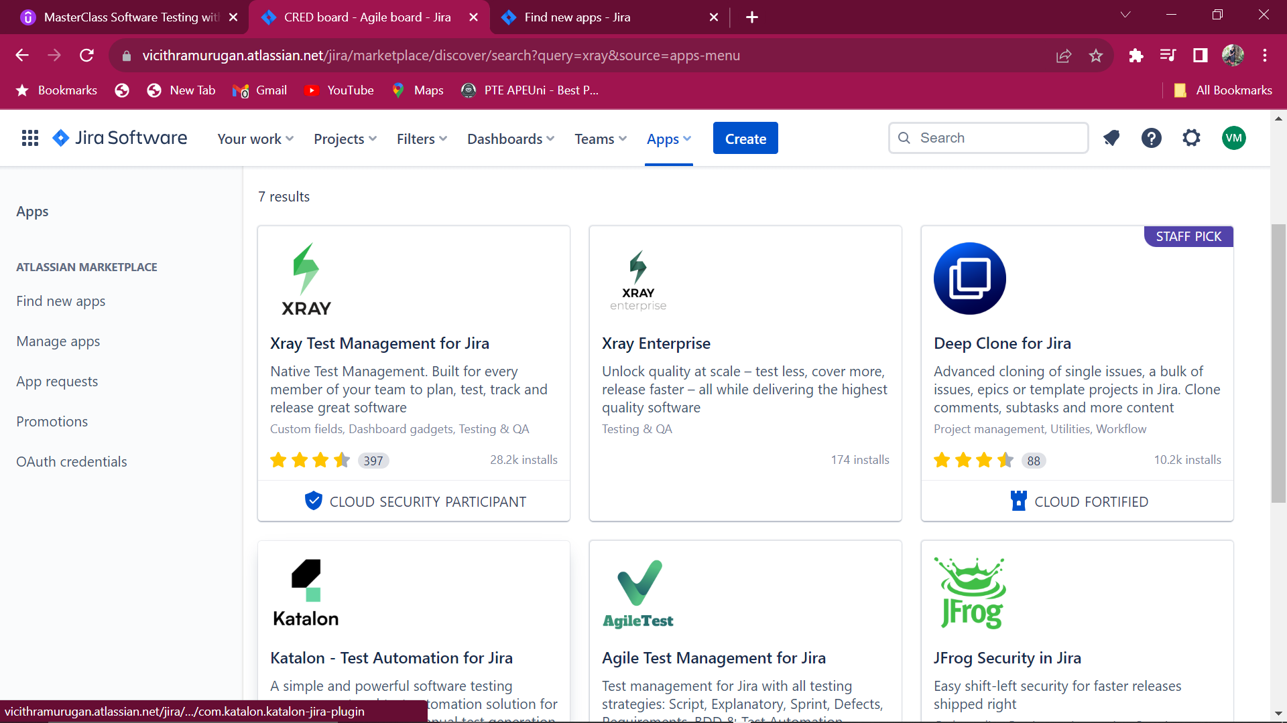

**Configure the XRAY app and add to the project**

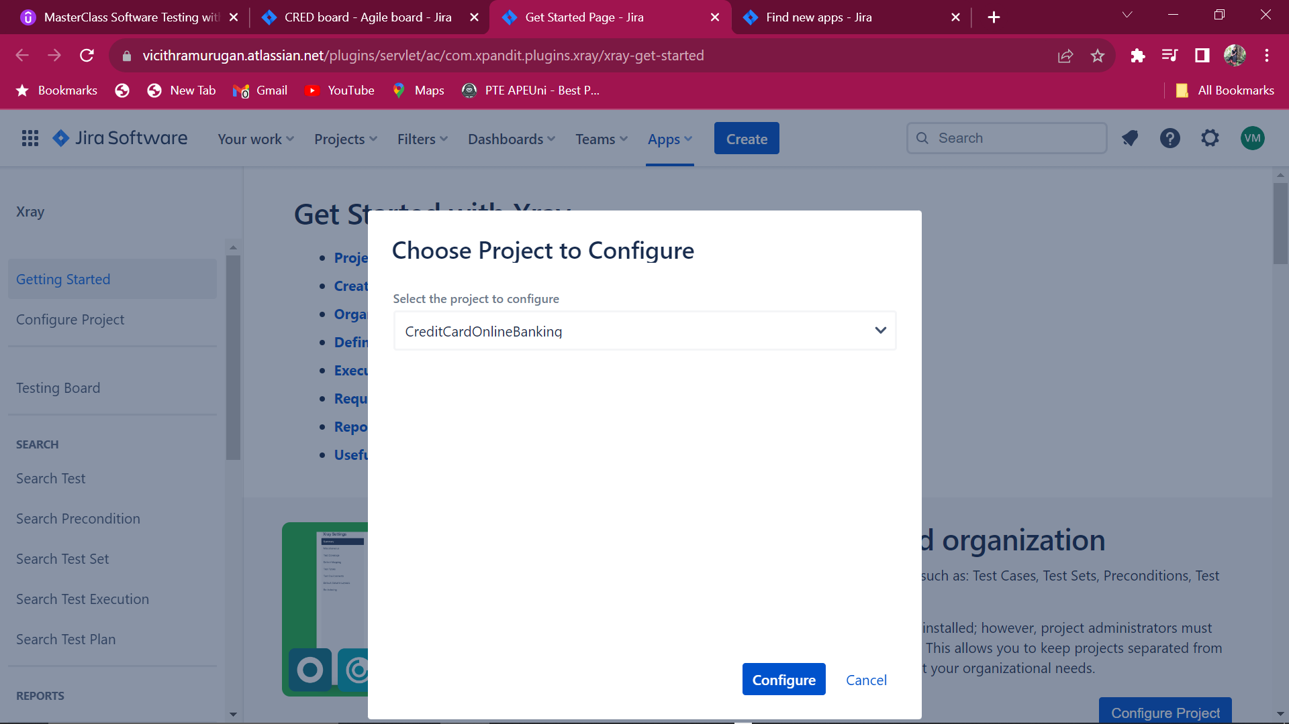

**Create an Issue type “Test” and add the Password reset scenario.**

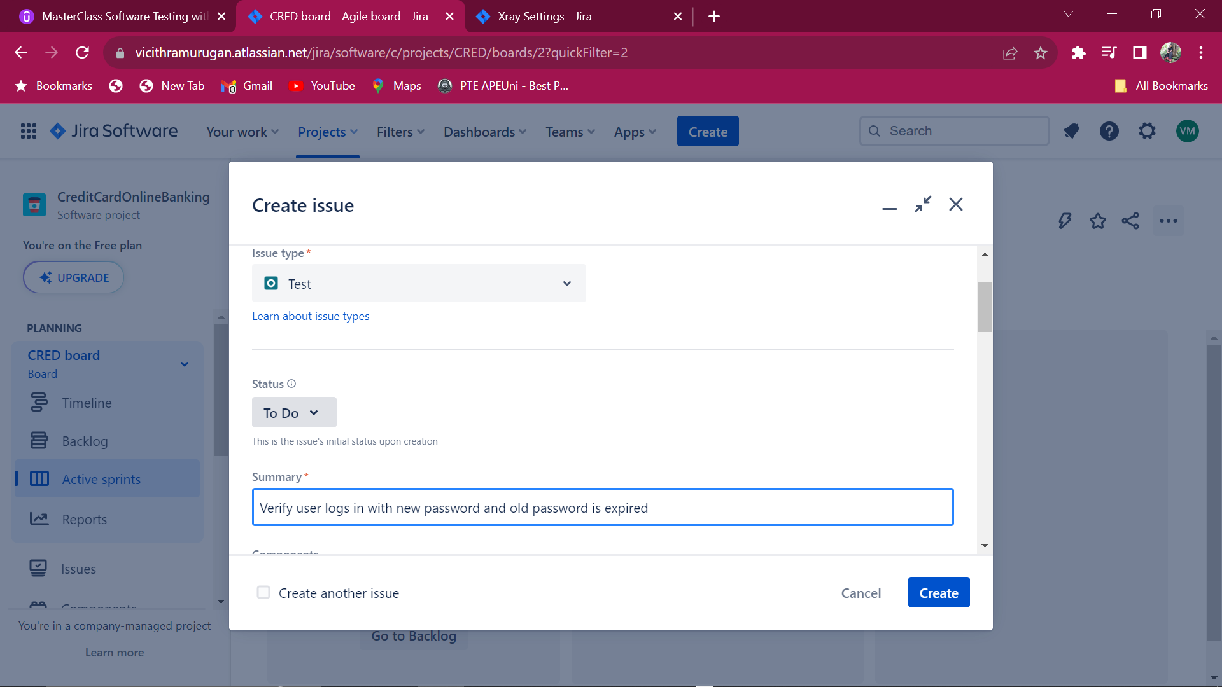

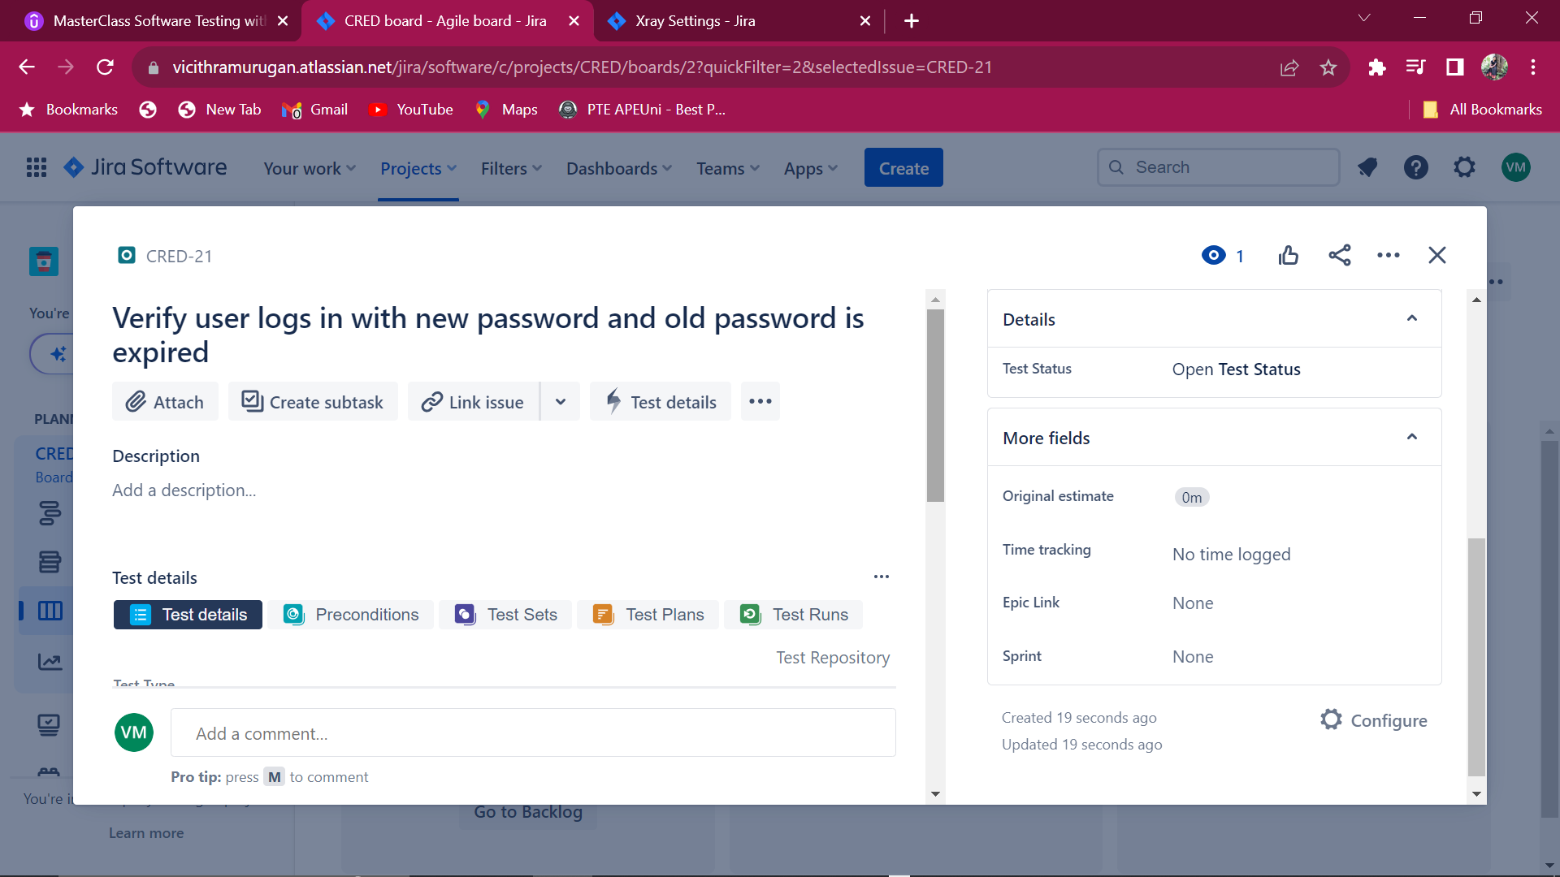

**Add Test Steps for the test case**

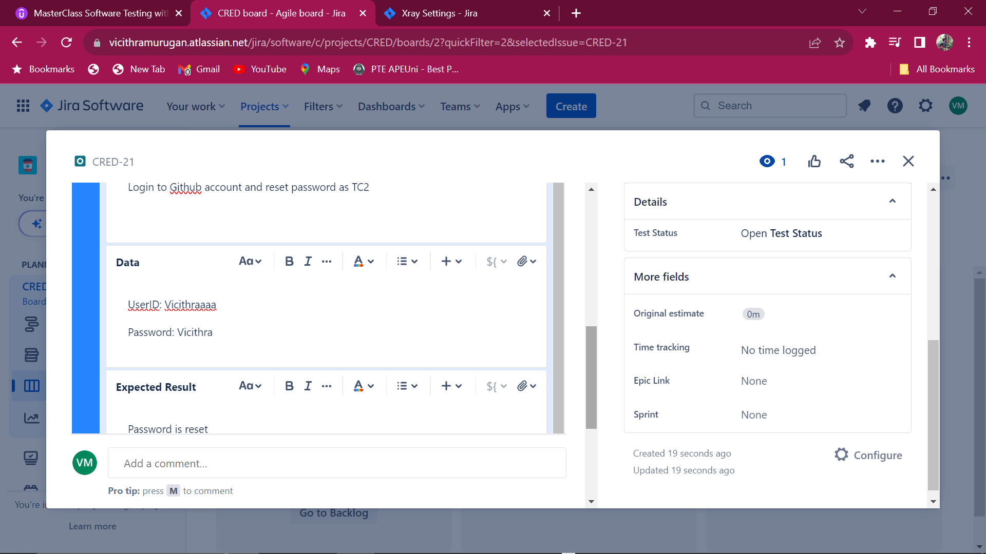

**Test steps created for the test case.**

**Adding Preconditions**

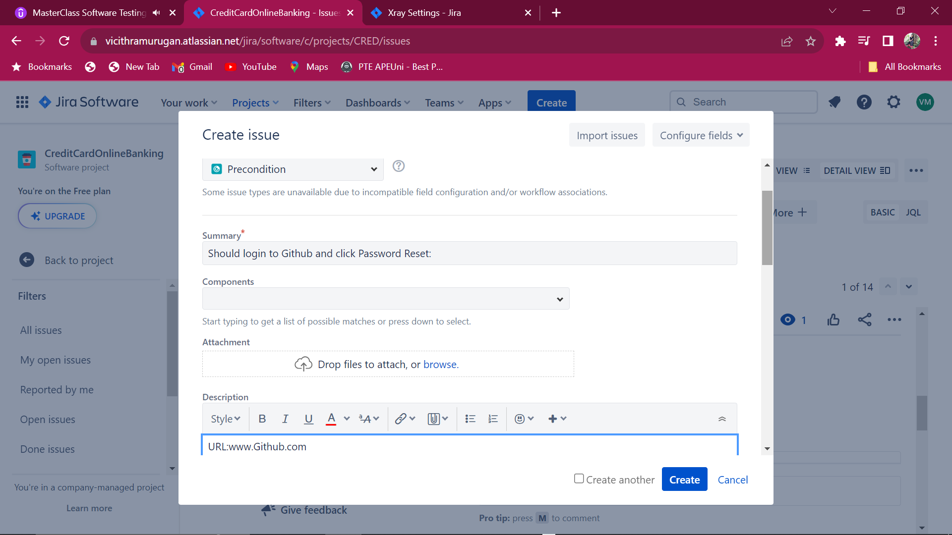 **Adding Test Set or Test Scenario**

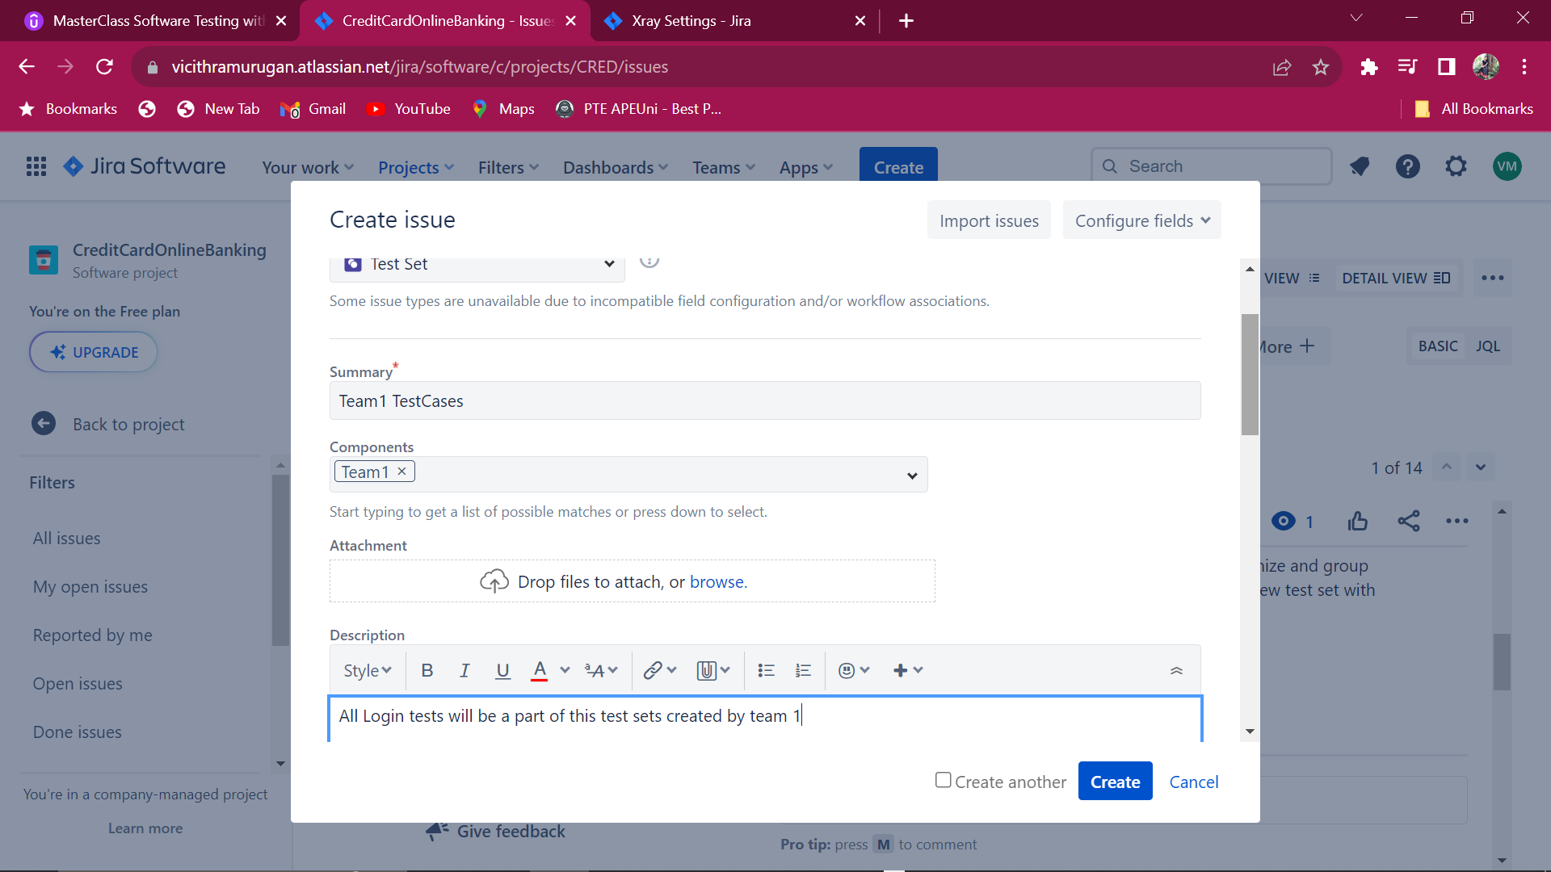

**All the test cases with test steps has been updated**

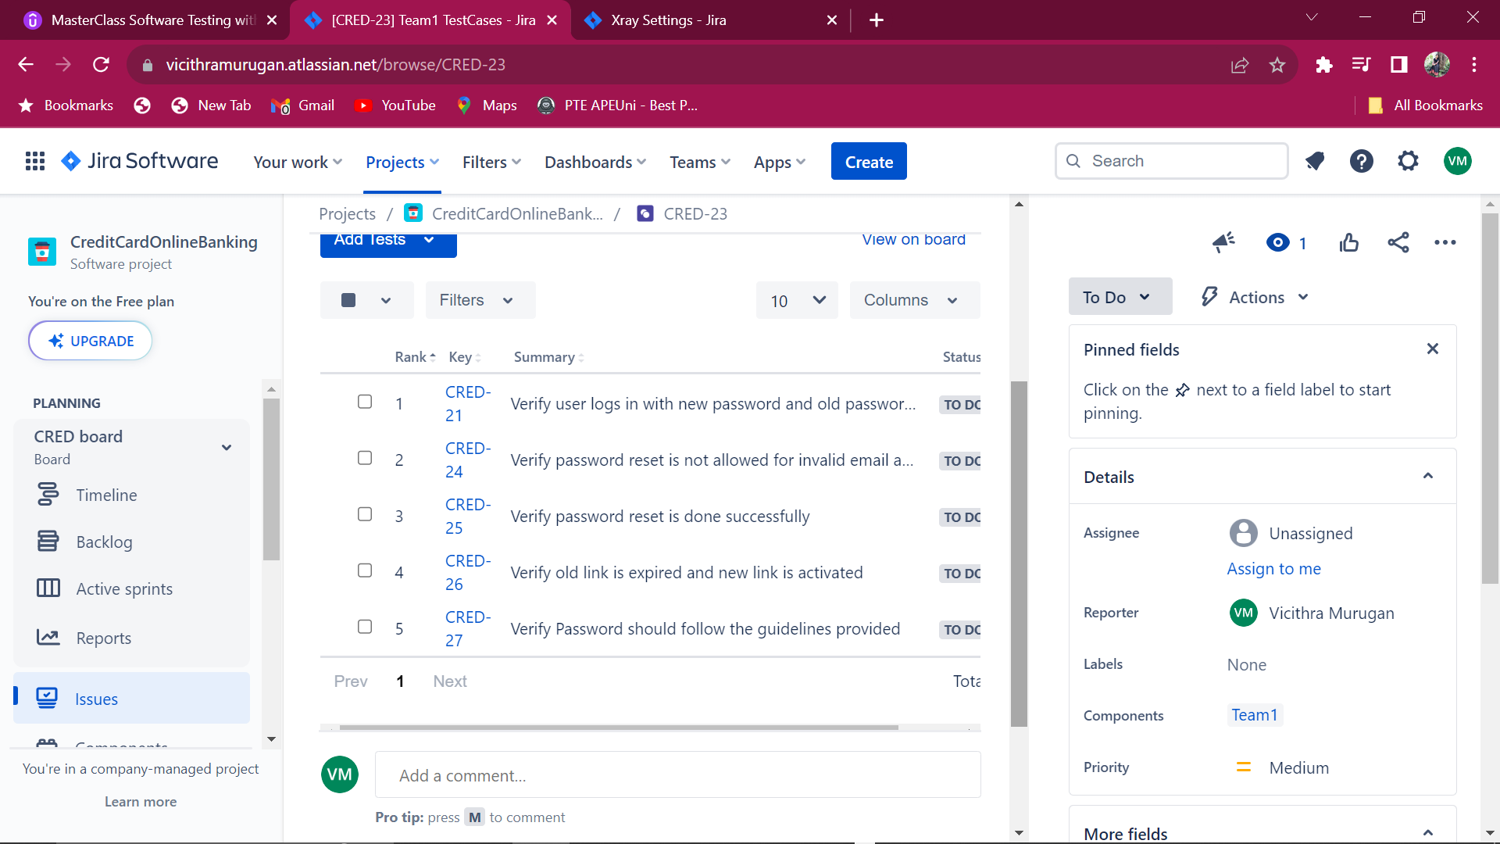

Regression testing are the priority functional testing before the release.Hence priority testsets and test are added to test plan

**Creating test Plans and adding testset before release.**

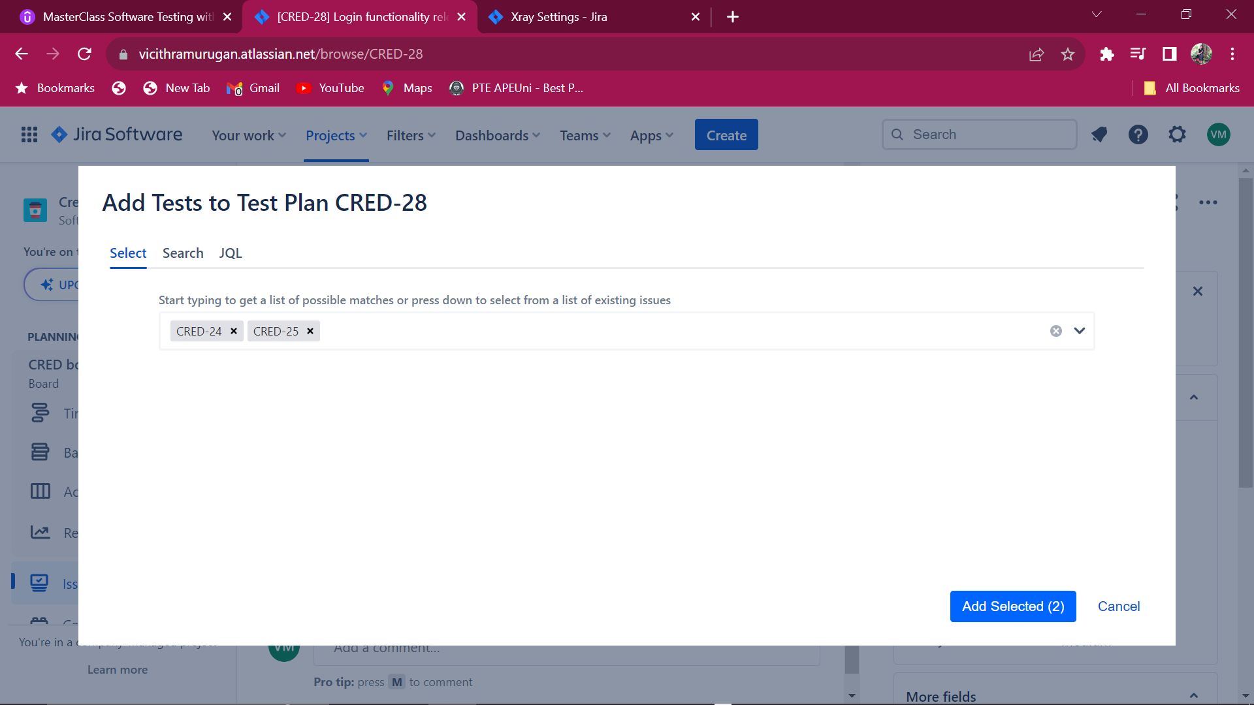

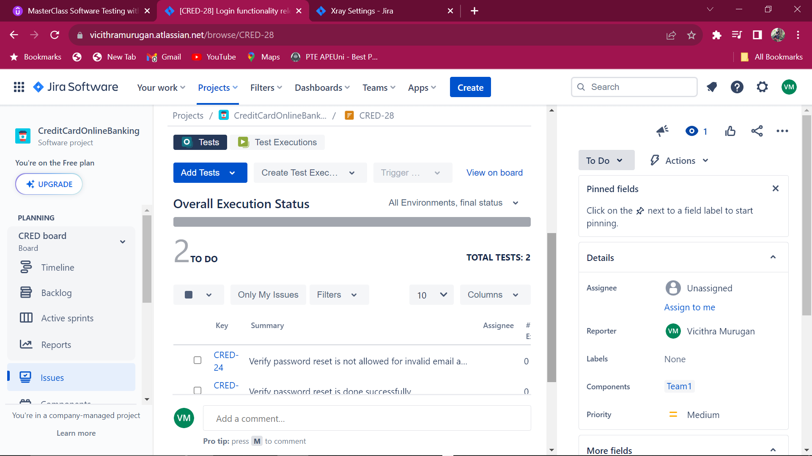

**Creating Test Execution**

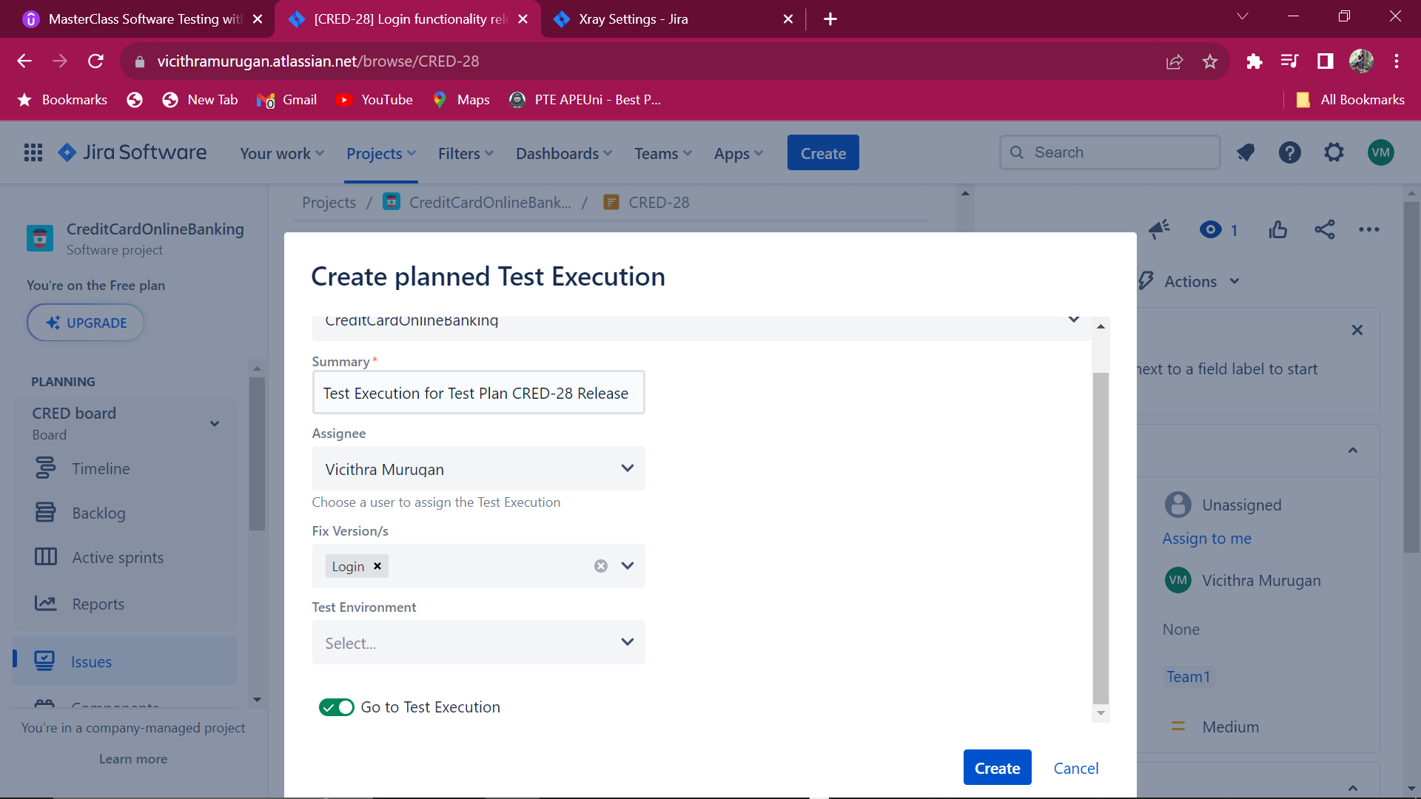

**Passing and failing the execution**

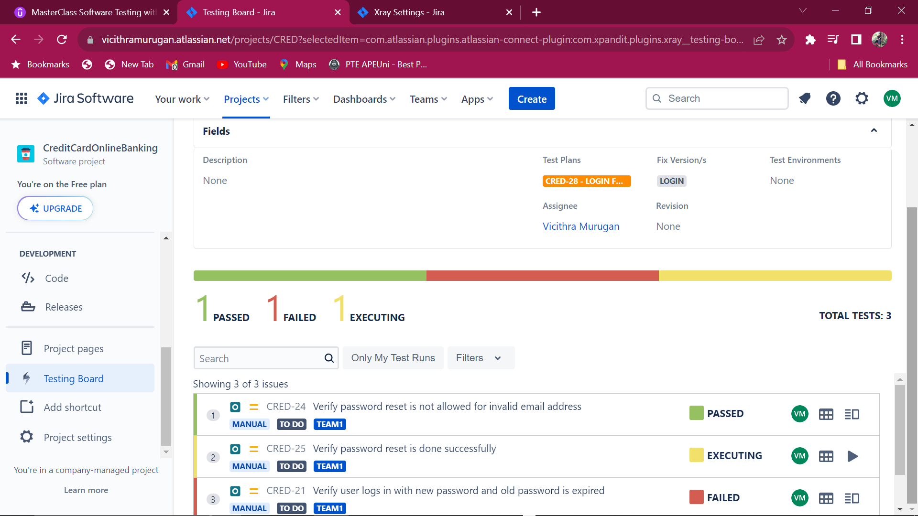

Linking issue for user story development

